

**EELU University**

***Faculty of computer and information technology***

***Course Flow***

|  |  |
| --- | --- |
| Rewan Amr Mahmoud | 20-01553 |
| Lamis Mahran Felfel | **20-00094** |
| Merna Osama Mahmoud | **20-00591** |
| Riham Mahmoud Mohamed | **20-01354** |
| Shrouk Elsayed Farag | **20-02001** |

**Prepared by:**

**Under Supervision Of:**

|  |  |
| --- | --- |
| **Dr/ Bassem Elhady** | **Eng/ Nourhan Salah** |
| **Professor at the Faculty of**  **Computers and Information at**  **EELU** | **Teaching assistant at the faculty of**  **Computers and Information at**  **EELU** |

**Table of contents:**

**Acknowledgment**

**Abstract**

**Chapter 1 Introduction**

**1.1 Overview of the Web Application**

**1.2 Purpose and Goals**

**Chapter 2 Project Background**

**2.1 Context of the project**

**2.2 Motivation for the project**

**2.3 Target audience/users**

**Chapter 3 Architecture and Functionality**

**3.1 System architecture overview**

**3.2 Database management system**

**Chapter 4 Features and Functionality**

**4.1 List and Description of key features**

**4.2 User roles and permissions**

**4.3 User interface design**

**Chapter 5 Implementation Details Course Recommendation**

**5.1 Development environment setup**

**5.2 Key algorithms or methodologies used**

**5.3** **Challenges faced and solutions**

**Chapter 6 Implementation Details Voice recognition**

**6.1 Development environment setup**

**6.2 Key algorithms or methodologies used**

**6.3 Challenges faced and solutions**

**Chapter 7 Testing and Quality Assurance**

**7.1** **Testing strategies and methodologies**

**7.2** **Types of testing conducted (e.g., unit testing, integration testing)**

**7.3** **Results of testing and any bug fixes**

**Chapter 8 Deployment**

**8.1** **Deployment process**

**8.2** **Hosting environment**

**8.3** **Scalability considerations**

**Chapter 9 Maintenance and Support**

**9.1** **Future plans for the application**

**9.2** **Potential updates or enhancements**

**Chapter 10 User Documentation**

**10.1 FAQs**

**Chapter 11 Conclusion**

**11.1 Summary of achievements**

**11.2 Lessons learned**

**Chapter 12 References**

**12.1 List of resources used**

**Chapter 13 Appendices**

**13.1 Additional technical details**

**13.2 Diagrams**

**13.3 Code snippets**

**Acknowledgement**

We would like to take a moment to express our gratitude, first and foremost, for the generosity of our god, for bringing us to this moment.

We have worked hard and faced many hardships for the success of this project.

We would like to thank the many individuals and organizations for their support, encouragement, and insightful feedback throughout the preparation process.

We would also like to express our deep appreciation and gratitude to [Dr. Basem Elhady], and many thanks to [Engineer: Nourhan Salah] whose guidance and experience were invaluable, and Finally, we would like to thank the public for their time and interest. It's great to be here today.

**Abstract**

In today's fast-paced world, the digitization of education has revolutionized the way we learn and access information. With the advent of platforms like Udemy and Khan Academy, individuals have unprecedented access to a vast array of courses covering diverse subjects and skill levels. However, navigating through this abundance of online educational content can sometimes be overwhelming.

This is where Course Flow comes into play. By offering a centralized platform for educational institutions to manage and display their course schedules, Course Flow simplifies the process for both students and administrators. Gone are the days of manually sifting through countless websites or spreadsheets to find relevant course information. Instead, Course Flow provides a user-friendly interface where students can easily search for courses based on their interests, academic requirements, or career goals.

Furthermore, Course Flow's recommendation feature adds another layer of convenience and personalization to the learning experience. This not only saves time but also helps users discover new topics or skills they may not have considered before.

Additionally, the integration of speech-to-text functionality in Course Flow enhances user interaction by allowing students to use voice commands for searching for courses, making the process even more seamless and accessible.

Moreover, Course Flow's integration with platforms like Udemy enhances its functionality by providing access to a wealth of supplementary learning resources. Whether users are looking for in-depth tutorials, hands-on projects, or expert-led lectures, Course Flow can point them in the right direction.

**1.Introduction**

**1.1 Overview of the Web Application**

* Provide a user-friendly and efficient online platform for managing educational courses.
* Organize course schedules effectively for educational institutions.
* Enhance the user experience for administrators, instructors, and students in accessing course schedules.
* Improve the accuracy and effectiveness of the course recommendation system to better meet students' needs.
* Encourage students to search for and select courses that align with their personal interests.
* Offer a simplified and user-friendly interface for administration to manage courses and schedules.
* Provide a simplified and user-friendly interface for students to view course schedules and enrollments.
* Facilitate the course registration process and subscription management for students and instructors.
* The speech-to-text functionality is integrated into the search bar of a course recommendation system to improve user accessibility and convenience. This feature allows users to use their voice to search for courses instead of typing, making the system more user-friendly and efficient.

**1.2 Purpose and Goals**

**Purpose**

* Improving the learning process for students and facilitating course management for professors by providing a comprehensive and innovative learning environment.
* The platform also aims to use artificial intelligence technologies to improve the learning experience and effectively direct students to appropriate courses.

**Goals**

1. **How can an admin add new courses to the platform?**

Allows the admin to create and add new courses via an easy-to-use course management interface.

1. **What are the steps necessary to review and approve applications to join courses?**

The admin can review student applications and approve or reject them based on pre-defined criteria.

1. **How can the admin review and modify the course schedule?**

The admin can access the course schedule and easily set appointments and classes and modify them as needed.

1. **What are the options available to the admin to modify his profile?**

The admin can update his profile information such as name, email and password.

1. **How can students choose the courses they want to join?**

The application provides a list of courses available to join and students can choose the courses that suit their interests and educational goals.

1. **What are the necessary steps to request approval to enroll in specific courses?**

Students can request to join specific courses and send requests for approval by the admin responsible for the course.

1. **How can students access the course schedule and learn about academic dates and dates?**

Students can view their course schedule and easily know the timing and dates of classes via the schedule page.

1. **What options are available to students to modify their personal files?**

Students can update their profile data such as name, email, mobile number, address and password.

1. **Enhancing Search Experience?**

Providing accurate and targeted recommendations to students when searching for courses using the course title to improve the search experience and quickly find suitable courses, we have integrated a speech-to-text feature in the search bar. This allows students to verbally input their search queries, making the process faster and more convenient.

1. **Offering Unique Learning Experience?**

Delivering customized and relevant courses to meet the individual needs and personal interests of students, thereby enhancing effective learning and improving academic outcomes.

**2.Project Background**

2.1 **Context of the Project****:**

The project, Course Flow, is a user-friendly and efficient online platform tailored for educational institutions such as universities or training centers to manage and display their course schedules effectively. Its design focuses on streamlining the scheduling and organizing processes, providing an intuitive interface for administrators and students to access and interact with schedule information easily. Additionally, the platform incorporates a unique feature that recommends similar courses on Udemy based on user searches, enhancing the educational experience by connecting users with relevant learning opportunities outside the institution. This dual functionality addresses the need for a responsive, and user-centered approach in educational scheduling and online learning recommendations.

**2.2 Motivation for the project****:**

The motivation for the Course Flow project is deeply rooted in addressing the significant challenges and inefficiencies encountered by educational institutions in managing and optimizing course schedules. Many of these institutions grapple with systems that are outdated, lack transparency, and are not adaptable to changing educational landscapes. These systems often result in inefficient scheduling, underutilized resources, and a lack of user-friendly interfaces for both students and administrators.

Recognizing these challenges, the Course Flow project aims to revolutionize the way educational institutions manage their course schedules. By developing a user-friendly and efficient online platform, the project seeks to streamline the process of scheduling and organizing courses. This includes providing intuitive interfaces for administrators and students, thereby enhancing their ability to access and interact with schedule information easily.

Moreover, the project extends its utility beyond more scheduling by incorporating a recommendation system for similar courses available on Udemy. This feature is motivated by the desire to enhance the educational experience, offering users the ability to explore and engage with additional learning opportunities that align with their interests or academic pursuits.

In essence, the motivation behind Course Flow is to address and overcome the prevalent inefficiencies in educational scheduling systems. By offering a solution that is both innovative and user-centered, the project endeavors to significantly improve the scheduling and learning experience within educational institutions, making it more efficient, transparent, and adaptable to the needs of students and administrators alike.

**2.3 Target audience/users****:**

The target audience for the Course Flow project encompasses a broad range of users within educational settings, particularly focusing on:

* **Educational Institutions:** Universities and training centers looking for a streamlined and efficient way to manage their course schedules. This includes administrators responsible for organizing and updating course offerings and schedules.
* **Students:** Individuals enrolled in these institutions who seek an intuitive and accessible platform to view course schedules, enroll in classes, and receive personalized course recommendations. Students benefit from a system that simplifies the process of managing their academic schedules and enhances their learning experience by suggesting additional courses on platforms like Udemy.
* **Educators:** Faculty and staff who require a system to efficiently plan, schedule, and communicate their courses to students. While the document primarily mentions administrators and students, educators also indirectly benefit from the efficiencies and improvements in course management and student engagement that the platform provides.
* **Lifelong Learners:** Users interested in expanding their knowledge and skills through online courses on platforms such as Udemy. By integrating a recommendation system, the project caters to individuals who are not just looking for academic courses but are also keen on personal and professional development through online learning.

This diverse target audience reflects the project's aim to enhance the educational ecosystem by facilitating better management of course schedules, improving access to educational resources, and fostering a culture of continuous learning and development.

**3. Architecture and Technologies Used**

**3.1 System architecture overview:**

- AI Course Recommendation:

The AI Course Recommendation System is designed to enhance the student experience by providing personalized and relevant course suggestions from the extensive Udemy catalog. The system's architecture involves several key components and processes:

1. **User Input**: The process begins with the user entering a query, such as specific topics like "cybersecurity." This input can be entered via text or through the newly integrated speech-to-text feature in the search bar, allowing for voice queries.
2. **Search Algorithm**: Upon receiving the user input, the system employs an advanced search algorithm to scan Udemy's comprehensive course catalog. This algorithm is designed to identify courses that potentially match the user's query based on keywords, topics, and other relevant criteria.
3. **Ranking Algorithm**: Once potential matches are identified, a finely tuned ranking algorithm evaluates the relevance of each course. This evaluation considers several factors, including:
   * **Course Content**: The depth and breadth of the topics covered.
   * **Ratings**: User ratings and reviews to gauge the quality and satisfaction levels.
   * **User Feedback**: Comments and feedback from previous learners.
   * **Engagement Metrics**: Data on how users interact with the courses, such as completion rates and average time spent.
4. **Personalization Engine**: Leveraging machine learning methodologies, the system also considers the individual user's learning history, preferences, and behavior to tailor the recommendations. This ensures that the suggested courses are not only relevant to the query but also aligned with the user's personal learning objectives and past interactions.
5. **Curated Course List**: Finally, the system compiles a curated list of courses, ranked by relevance. This list is presented to the user in a user-friendly format, enabling them to quickly find and select courses that best fit their educational goals.
6. **User Interface**: The interface is designed to be intuitive, with features such as autocomplete, search filters, and clear categorization of results. The integration of the speech-to-text feature further enhances the usability, making it accessible for users who prefer voice input or have accessibility needs.

By combining these elements, the AI Course Recommendation System ensures that students receive accurate, personalized, and high-quality course suggestions, facilitating a more efficient and satisfying learning experience on Udemy.

-Admin:

1- login form:

Login Credentials

- Purpose: The primary function of the login form is to authenticate users before granting access to the secure areas of the application or website. This process helps in ensuring that sensitive information and functionalities are accessible only to authorized users.

- How It Works: Users are required to enter their email address and a password that they have previously set up or been assigned. The email serves as a unique identifier for the user, while the password acts as a secret key that should be known only to the user and securely stored in the application's database.

- Verification Process: Once the user submits their login credentials, the system compares the entered email and password with the information stored in its database. If the credentials match, the system verifies the user's identity, and access is granted. If there's a mismatch, access is denied, and the user is usually informed of the incorrect input.

Password Reset Functionality

- Need for Password Reset: Users may forget their passwords or need to reset them for security reasons. The password reset functionality provides a secure way for users to regain access to their accounts without compromising their security.

- Process:

1. Email Verification: The user initiates the password reset process by submitting their email address through the login form or a dedicated password reset page. The system checks if the submitted email is associated with an existing account.

2. Reset Link: If the email is valid, the system generates a unique, time-sensitive link and sends it to the user's email address. This link directs the user to a password reset page.

3. Resetting the Password: Once the user clicks on the provided link and is verified (usually by checking if the link hasn't expired and matches the user's identifier), they are redirected to a page where they can set a new password. The system then updates the user's account with the new password, allowing the user to log in with the new credentials.

2- Add Course:

The "Add Course" functionality is designed to streamline the process of incorporating new courses into an educational or training institution's offerings. It allows administrators or instructors to input detailed information about each course into a database or management system. This data is crucial for organizing course schedules, managing enrollment, and ensuring that all courses offered meet the institution's standards and students' needs. Here's a breakdown of the key components of the "Add Course" functionality based on the table columns you've provided:

1. **Course ID**: This is a unique identifier assigned to each course. It serves as a primary key in the database, ensuring that each course can be easily tracked and referenced without confusion. The Course ID is critical for internal management, allowing administrators and instructors to quickly access course information, enroll students, and manage course-related logistics.
2. **Course Type**: This field specifies the category or specialization of the course, such as "Flutter" for courses focused on Flutter development or "Python" for Python programming courses. Identifying the course type helps in organizing courses by their subject matter, making it easier for students to find courses that match their interests and for the institution to manage its curriculum offerings effectively.
3. **Course Name**: The course name provides a descriptive title for the course, facilitating easy identification and communication about the course. It should be concise yet descriptive enough to give students a clear idea of the course content and objectives.
4. **Seat Limit**: This indicates the maximum number of students that can enroll in the course. Setting a seat limit is essential for managing classroom sizes, ensuring that each student receives adequate attention and resources, and maintaining the quality of instruction. It also helps in planning for space and resource allocation.
5. **Course Fee**: This field is for inputting the cost associated with enrolling in the course. The course fee might cover tuition, access to course materials, and other resources provided during the course. Clearly specifying the course fee is crucial for financial planning for both the institution and the students.
6. **Exam Fee**: This specifies any additional costs related to examinations or assessments within the course. Not all courses may have an exam fee, but for those that do, it's important to outline these costs upfront so that students are aware of all expenses associated with the course.

3- Courses:

* The Courses Table page is an indispensable resource designed to empower administrators with efficient tools for managing and monitoring course information within a system or platform.
* This page is meticulously crafted to streamline the process of handling a multitude of courses, offering an array of functionalities that facilitate organization, accessibility, and manipulation of data.
* At its core, the Courses Table page mirrors the layout of the Add Course page, ensuring consistency and coherence across different sections of the system. In addition to displaying fundamental information about each course, such as its name, ID, and pertinent details, the table also incorporates interactive elements, notably Edit and Delete buttons, granting administrators granular control over individual course entries.
* One of the hallmark features of the Courses Table page is its robust sorting mechanism, which enables administrators to swiftly arrange courses in alphabetical or numerical order by simply clicking on the respective column headers.
* This intuitive functionality significantly enhances the navigational experience, allowing users to effortlessly locate specific courses or arrange them according to predefined criteria.
* Furthermore, the table offers powerful filtering capabilities, empowering administrators to refine the displayed courses based on specific parameters or criteria.
* Whether it's filtering courses by category, enrollment status, or any other customizable attribute, this feature facilitates targeted data analysis and retrieval, saving valuable time and effort in the process.
* Moreover, the inclusion of a dedicated search bar elevates the user experience by providing a quick and convenient method for locating a particular course within the expansive dataset.
* Administrators can effortlessly input the name or ID of the desired course into the search bar, prompting instantaneous retrieval of relevant entries and eliminating the need for manual scanning or browsing.
* To accommodate systems with a large volume of courses, the Courses Table page implements a sophisticated pagination system, allowing administrators to navigate seamlessly through multiple pages of courses.
* This intuitive pagination control ensures optimal performance and user experience, preventing information overload while maintaining accessibility to all course entries.
* In essence, the Courses Table page represents a cornerstone of administrative functionality within the system, serving as a centralized hub for managing, organizing, and monitoring course information. By leveraging its diverse array of interactive features, administrators can efficiently navigate, manipulate, and extract insights from the wealth of data at their disposal, ultimately enhancing productivity, decision-making, and overall system performance.

4-Approval

* Approval is a pivotal process within the framework of a centralized system designed to manage course requests submitted by students.
* This system serves as a hub where such requests are meticulously reviewed, processed, and ultimately approved or rejected based on various criteria and considerations.
* At its core, the approval mechanism aims to streamline the workflow associated with handling course requests, ensuring efficiency, accuracy, and transparency throughout the process.
* The approval system typically features a dedicated page that serves as the interface through which all course requests are managed.
* This page serves as the nerve center, consolidating all incoming requests into a cohesive and accessible format for review and action by administrators or designated personnel.
* Its primary function is to provide a centralized platform where requests can be evaluated, decisions can be made, and communication with students can be facilitated seamlessly.
* Central to the approval system is the Request List, a comprehensive section within the page that presents an overview of all pending course requests. This list serves as a snapshot of the current situation, displaying essential details pertaining to each request, including the student's name, roll number or identification, the course requested, and any additional pertinent information provided by the student.
* This structured presentation enables administrators to quickly assess the nature and scope of each request, laying the groundwork for informed decision-making.
* The approval process itself is driven by a set of actionable commands, prominently featured within the interface for ease of access and navigation. Two primary actions are typically available: Approve and Reject.
* To approve a request, administrators simply need to click the "Approve" button associated with the respective request. This action signifies authorization for the student to enroll in the requested course, effectively giving the green light for their academic pursuit.
* Conversely, the "Reject" button offers a mechanism for administrators to decline a course request deemed unsuitable or ineligible for approval. Alongside this action, administrators have the option to provide feedback to the student, offering clarity or guidance regarding the reasons for rejection.
* This feedback mechanism serves as a valuable means of communication, fostering transparency and understanding between administrators and students.
* In essence, the approval system represents a dynamic and responsive framework for managing course requests within an educational institution or organizational setting.
* By centralizing the review process, providing actionable commands, and facilitating communication with stakeholders, the system ensures a smooth and transparent workflow conducive to effective academic administration.

5-schedule

The Schedule Management page serves as a central hub for organizing and managing scheduled courses within a system.

* At its core, it features an interactive calendar interface designed to provide users with a comprehensive overview of their scheduled activities over a period.
* This calendar allows users to navigate seamlessly through different days, enabling them to gain insights into their upcoming commitments and plan their time effectively.
* One of the key functionalities of the Schedule Management page is its ability to facilitate the scheduling of course meetings for students.
* This feature typically involves administrative controls, allowing authorized personnel such as administrators or educators to set specific meeting times for various courses.
* By accessing the scheduling interface, administrators can input relevant details such as course names, meeting times, and locations, effectively organizing the academic agenda for students.
* Moreover, the Schedule Management page offers several tools and options to enhance usability and efficiency. Additionally, a 'clear schedule' function enables users to remove any previously scheduled courses and providing a clean slate for rescheduling or planning new activities.
* Another useful feature provided by the Schedule Management page is the option to 'uncheck all,' which allows users to quickly deselect all scheduled courses with a single action. This functionality is particularly handy when users need to make significant changes to their schedule or start from scratch.
* Lastly, the Schedule Management page typically includes a 'print' functionality, enabling users to generate hard copies of their schedule for reference or offline use.
* This feature is particularly beneficial for students who prefer physical copies or need to present their schedule in various contexts, such as meetings with advisors or academic counselors.
* In summary, the Schedule Management page serves as a centralized platform for organizing, managing, and accessing scheduled courses.
* By offering an interactive calendar interface along with various administrative controls and user-friendly features, it empowers users to effectively plan their academic activities, optimize their time, and stay organized throughout their educational journey.

6- Edit proﬁle:

* The Edit Profile feature within a digital platform as a personalized space where users can effectively modify and update their profile information.
* This page is designed to offer users a seamless and intuitive interface to manage their individual details.

At its core, the Edit Profile page serves as a central hub for users to adjust various aspects of their profile. This includes fundamental details such as their email address, which is often a primary point of contact for communication within the platform. Users can easily update their email address to ensure they receive important notifications and correspondence.

the Edit Profile page typically includes fields for password management. This includes the provision for users to update their password by entering their old password along with the desired new password. This step is crucial for maintaining account security and ensuring that users have control over their login credentials. The inclusion of a "Confirm Password" field helps prevent inadvertent errors and ensures that users correctly input their new password.

Overall, the Edit Profile page offers a comprehensive set of fields that represent various aspects of a user's profile. From basic personal details to essential security measures, this feature provides users with the flexibility and control they need to maintain an accurate and secure profile within the digital platform. By offering a user-friendly interface and intuitive design, the Edit Profile page enhances the overall user experience, empowering individuals to manage their profile information effectively and efficiently.

_______________________________________________________

* Student:

1-Login & Registration form

A Login & Registration form is an essential component of any system that requires user authentication and account creation. In this system, users are provided with two primary functionalities: logging in to access their account and registration to create a new account. The process ensures secure access to the system's features while maintaining user privacy and data integrity.

Login Credentials:

1. Roll Number & Password: Users sign in using their unique Roll Number, which serves as their identifier, along with a password associated with their account. This combination of credentials acts as a secure means of authentication.

2. Verification Process: Upon submitting the login credentials, the system verifies the provided information against the stored data in the database. This verification process ensures that only authorized users gain access to the system's features.

Password Reset Functionality:

1. Email Verification: Users have the option to reset their passwords in case they forget or need to change them for security reasons. This process begins by initiating a password reset request via email verification.

2. Submission and Link: Upon submitting the email for password reset, a unique link is generated and sent to the user's email address. This link serves as a secure pathway for the user to access the password reset page.

3. Password Reset Page: Clicking on the provided link directs the user to a password reset page where they can input a new password. This page ensures security by confirming the user's identity through the email verification process.

4. New Password Input: After successful verification, the user is presented with input fields to enter their new password. This step completes the password reset process, providing users with a secure means to regain access to their account.

Registration Credentials:

1. User-Friendly Form: The registration process is designed to be user-friendly, simplifying the creation of a new student account. This approach ensures a seamless experience for users, encouraging participation and adoption of the system.

2. Essential Fields: The registration form includes essential fields required to create a new account. These fields typically include:

- Full Name: To uniquely identify the user.

- Roll Number: A unique identifier for the student within the system.

- Email: A valid email address for communication and account verification purposes.

- Mobile Number: Contact information for the user, facilitating communication if necessary.

- Address: Optional but may be included for additional context or communication purposes.

- Password & Confirm Password: Secure fields for the user to set up their account password, ensuring data confidentiality and integrity.

In summary, the Login & Registration form provides users with secure access to the system's features while maintaining data integrity and user privacy. Through a combination of authentication mechanisms such as Roll Number and password, along with additional functionalities like password reset via email verification and user-friendly registration forms, the system ensures a seamless and secure user experience.

-Select Course:

A Select Course page serves as a centralized hub aimed at simplifying the intricate process of choosing and enrolling in courses. It offers users a streamlined and intuitive journey, from browsing available courses to finalizing enrollment, ensuring a seamless and efficient experience.

At the core of the "Select Course" page is the Course Catalog. This comprehensive repository showcases all available courses within an institution or organization. Each course entry in the catalog is rich with essential details, including Course ID, Course Type, Course Name, and Exam Type. This organized presentation enables users to swiftly navigate through the vast array of offerings and locate courses that align with their interests and requirements.

The Selection Interface is a pivotal feature, empowering users to actively participate in the course selection process. Through this interface, users can mark their desired courses using intuitive selection mechanisms such as checkboxes or buttons. This interactive element grants user’s autonomy and control over their choices, facilitating a personalized and tailored course selection experience.

Once users have made their selections, the page guides them through the Final Confirmation step. This crucial stage acts as a checkpoint, allowing users to review their chosen courses before proceeding with enrollment. A conﬁrmation prompt prompts users to verify their selections and finalize their enrollment decisions. This ensures accuracy and minimizes errors, mitigating the risk of enrolling in unintended courses.

In summary, the "Select Course" platform serves as a user-centric solution that streamlines the course selection and enrollment process. By providing a comprehensive Course Catalog, an intuitive Selection Interface, and a Final Confirmation mechanism, the platform enhances user convenience, efficiency, and satisfaction. Whether for students navigating their academic journey or professionals seeking professional development opportunities, Select Course page simplifies the path to acquiring knowledge and skills.

-Pending Courses:

The "Pending Courses" page on the student side of the platform serves as a centralized hub where students can track and manage their course requests that are currently in a pending state. These pending courses are those which have been submitted by students but are yet to be approved or processed further by administrators or instructors. The page is designed to streamline the process of monitoring pending course requests, providing students with transparency and control over their academic pursuits. Here's a detailed breakdown of the key components of the Pending Courses page:

1. Course Request List:

The core feature of the page is the Course Request List, which presents a comprehensive overview of all courses that are currently pending approval or further processing. This list provides students with a centralized view of their pending course requests, allowing them to quickly assess the status of each request and take appropriate actions as needed.

2. Course Details:

Within the Course Request List, each pending course is accompanied by relevant information to help students identify and differentiate between their various requests. This includes details such as the Course ID, Course Type (e.g., elective, core requirement), Course Name, and the associated instructor or faculty member responsible for the course. By providing these details upfront, the page ensures that students have all the necessary information at their fingertips to make informed decisions about their pending courses.

3. Action Buttons:

To facilitate quick decision-making and actions, the Pending Courses page includes action buttons next to each pending course. These action buttons typically include options such as "delete" or "cancel," allowing students to withdraw their pending course requests if necessary. By incorporating these action buttons directly within the Course Request List, the page empowers students to take proactive steps in managing their pending courses without the need for additional navigation or interactions.

Overall, the Pending Courses page on the student side of the platform serves as a user-friendly interface for students to monitor, track, and manage their pending course requests effectively. By providing a centralized location for accessing course details and taking action, the page enhances the student experience and promotes greater efficiency in the course request process. Additionally, the inclusion of action buttons ensures that students have the flexibility to modify or withdraw their pending course requests as needed, further enhancing their control over their academic journey.

-Approved request:

The "Approved Requests" page on the student side of the educational platform serves as a pivotal interface where students can conveniently access a comprehensive list of courses that have undergone the approval process successfully. This page plays a crucial role in informing students about the courses that have met the necessary criteria and are deemed ready for enrollment or further progression. Below is a detailed explanation of the key components and functionalities of the "Approved Requests" page:

1. Approved Course List:

- At the heart of the page lies the "Approved Course List," which serves as the primary focal point for students seeking to explore their available course options.

- This list provides a detailed inventory of courses that have successfully passed through the rigorous approval process, ensuring that they meet the predefined standards and criteria set forth by the educational institution or platform.

- Each course entry within the list is accompanied by essential details, enabling students to make informed decisions regarding their educational pursuits.

2. Course Details:

- Within the "Approved Course List," students can delve into the specifics of each approved course through the "Course Details" section.

- This section furnishes students with crucial information about the approved courses, offering insights into various facets such as the course type, course title, exam type, and course fee.

- The inclusion of such comprehensive details empowers students to assess the suitability of each course based on their individual preferences, academic requirements, and financial considerations.

3. Type of Course:

- One of the pivotal components of the "Course Details" section is the classification of courses based on their type. This categorization helps students discern between different educational offerings, such as foundational courses, elective courses, specialization tracks, or advanced seminars.

- By clearly indicating the type of each approved course, students can align their educational objectives with their academic interests and career aspirations more effectively.

4. Course Title:

- The course title serves as a succinct descriptor of the subject matter covered within each approved course. It provides students with a glimpse into the thematic focus and content area of the course, facilitating informed decision-making regarding enrollment.

5. Exam Type:

- Another critical aspect highlighted in the "Course Details" section is the exam type associated with each approved course.

- This information elucidates the assessment methodology employed within the course, whether it entails traditional written examinations, practical assessments, project-based evaluations, or other forms of assessment.

6. Course Fee:

- The course fee represents a vital consideration for students planning to enroll in approved courses, as it delineates the financial commitment associated with each educational endeavor.

- By transparently disclosing the course fee alongside other pertinent details, the platform enables students to assess the affordability of courses and make informed decisions aligned with their budgetary constraints.

In summary, the "Approved Requests" page on the student side of the platform offers a user-friendly interface through which students can explore a curated selection of courses that have met the requisite standards for approval. By providing detailed course listings and comprehensive course details, the page empowers students to make well-informed decisions regarding their educational journey, facilitating a seamless and enriching learning experience.

-Schedule:

* The Student Schedule Management feature provides an essential tool for students to effectively organize their academic and extracurricular commitments.
* This feature consists of a dynamic and user-friendly interface where students can access and manage their schedules conveniently. At its core, the Schedule Management page offers an interactive calendar that showcases all scheduled courses, events, and other activities pertinent to the student's academic journey.
* One of the primary functionalities of the Student Schedule Management page is its interactive calendar display.
* Through this calendar, students can easily visualize their schedule across different timeframes, such as daily, weekly, or monthly views. This flexibility allows students to plan and coordinate their activities efficiently, ensuring they can balance their academic workload, attend classes, and participate in various extracurricular engagements seamlessly.
* The calendar interface offers intuitive navigation options, enabling students to swiftly move between dates and explore their schedules with ease.
* Whether they need to review upcoming assignments, check course meeting times, or mark important deadlines, the Schedule Management page provides a centralized platform for students to stay organized and on track with their academic responsibilities.
* Furthermore, the Student Schedule Management feature incorporates administrative control over course meeting times.
* This means that administrators have the authority to set and manage the timing of courses, ensuring consistency and coherence in the scheduling process.
* By centralizing this control within the administrative domain, the system can maintain accuracy and alignment with the academic curriculum, preventing conflicts and confusion for students.
* From the student's perspective, having access to a comprehensive and up-to-date schedule is invaluable for planning their academic journey effectively.
* Whether they are balancing multiple courses, attending lectures, participating in extracurricular activities, or managing personal commitments, the Schedule Management page serves as a crucial resource for staying organized and maximizing productivity.
* In summary, the Student Schedule Management feature offers a robust and user-centric solution for students to manage their schedules efficiently. With its interactive calendar interface, intuitive navigation options, and administrative control over course meeting times, students can optimize their time management, prioritize tasks, and stay on top of their academic responsibilities with confidence.

-Edit proﬁle:

The "Edit Profile" feature on the student side of a platform or application serves as a vital component of user interaction and personalization. This feature provides students with a dedicated space where they can modify and update their profile information according to their preferences and evolving circumstances. It serves as a user-friendly interface that empowers individuals to manage their personal details with ease, ensuring that the information presented is accurate, up-to-date, and relevant.

The Edit Profile page is designed to offer a comprehensive set of fields, each representing a different aspect of the user's profile. These fields typically include:

1. Email: This field allows users to update their email address, ensuring that communication and notifications from the platform are directed to the correct inbox.

2. Old Password: To maintain security, users are often required to authenticate their identity by entering their old password before making any changes to their profile.

3. New Password: This field enables users to update their password, enhancing account security and ensuring continued access to the platform.

4. Confirm Password: To prevent errors and ensure accuracy, users are prompted to re-enter their new password to confirm the change.

5. Mobile Number: Users have the option to update their mobile number, ensuring that they receive important notifications via text message or phone call.

6. Address: This field allows users to update their physical address, which may be necessary for various purposes such as shipping, billing, or location-based services.

The Edit Profile page typically features a user-friendly layout, with clear instructions and intuitive controls to guide users through the process of updating their information. Depending on the platform or application, additional features such as profile pictures, biographical information, or privacy settings may also be included.

By offering a comprehensive and accessible interface for profile management, the Edit Profile feature enhances the overall user experience, fostering a sense of control, security, and personalization. It empowers students to tailor their profile according to their individual needs and preferences, ultimately contributing to a more engaging and user-centric platform ecosystem.

**3.2 Database management system:**

A Database Management System (DBMS) is a sophisticated software system designed to manage databases. It provides users and programmers with a systematic way to create, retrieve, update, and manage data. DBMSs are crucial components in the modern data ecosystem, allowing for efficient data handling, storage, and security across various applications and platforms.

Core Components of a DBMS

1. Database Engine: The core service for accessing and processing data stored in a database. It allows for data manipulation and the execution of queries.

2. Database Schema: The structure of a database defined in a formal language. It describes the organization, data types, and relationships of the data.

3.Query Processor: Parses and interprets SQL queries. It transforms high-level queries into low-level instructions that the database engine can execute.

4. Transaction Management: Ensures data integrity and consistency across multiple transactions. It follows the ACID properties (Atomicity, Consistency, Isolation, Durability) to manage concurrent access and error handling.

5. Storage Management: Manages the way data is physically stored in databases. It handles data indexing, backups, and data retrieval mechanisms.

6. Database Security Management: Controls access to data. It includes mechanisms for authentication, authorization, and auditing to ensure that only authorized users can access the database.

7. Data Recovery and Backup: Ensures data safety through mechanisms for data backup and recovery. This component is critical for protecting data against physical or logical failures.

MySQL as a DBMS for Course Flow Projects

MySQL is an open-source relational database management system (RDBMS) that uses Structured Query Language (SQL) for database management. It's widely used for its reliability, scalability, and ease of use, making it an ideal choice for educational projects and course flow management systems.

Why MySQL for Educational Projects?

1. **Cost-Effective**: Being open source, it is free to use, which is particularly beneficial for educational projects with limited budgets.

2. Ease of Use: MySQL is well-documented and supported by a large community. Its straightforward syntax and comprehensive tools make it accessible for beginners and students.

3. Scalability: MySQL can handle both small and large amounts of data, making it suitable for projects that might grow in complexity and size.

4. Cross-Platform Support: MySQL runs on various platforms, including Windows, Linux, and macOS, offering flexibility in development environments.

5. Security: It offers robust data security features, including encryption and user access controls, which are essential for managing sensitive educational data.

A Database Management System (DBMS) like MySQL plays a pivotal role in managing data efficiently and securely in various applications, including course flow projects. By understanding the components and functionalities of a DBMS, and leveraging MySQL's features, educators and developers can build robust, scalable, and secure educational tools. This foundation is crucial for handling data-intensive tasks and supports the dynamic needs of educational environments.

**4. Features and Functionality**

**Ai**

* **4.1Description of key features:**

1. **Data Collection and Preprocessing**: The system collects and preprocesses data from the Udemy platform, including information about courses, instructors, and user interactions such as enrollments, reviews, and ratings.
2. **Content-Based Filtering**: The system recommends courses based on the content similarity to the courses previously taken or liked by the user. It analyzes course attributes such as title, description, category, instructor, and tags to make relevant suggestions.
3. **Personalized Recommendations**: The system tailors course recommendations to each user's unique preferences and learning behavior, ensuring a personalized learning experience. It continuously refines recommendations based on user feedback and interactions.
4. **Search Functionality**: Users can search for courses based on keywords, categories, instructors, or specific topics of interest. The search functionality may include filters and sorting options to help users find relevant courses more efficiently, **Speech Recognition**: Allows users to input search queries verbally, **Voice Command Processing**: Understands and processes natural language commands to execute searches.
5. **Recommendation Algorithms**: Various recommendation algorithms such as matrix factorization, k-nearest neighbors, and neural networks are used to analyze user data and generate course recommendations. These algorithms are continuously optimized to improve recommendation accuracy and relevance.

**Admin Side**

**4.1description of key features**

1. **Login Form**: The admin login form provides a secure gateway for administrators to access the system. It typically requires a username and password for authentication.
2. **Password Reset Functionality**: This feature allows administrators to reset their password in case they forget it or need to update it for security reasons.
3. **Add Course**: The table below captures key information about each course, enabling efficient management of course-related data, able Columns (**Course ID, Course Type, Course Name, Seat Limit, Course Fee, Exam Fee)**
4. **Courses**: Administrators can efficiently manage and monitor course information through features such as sorting, filtering, searching, and pagination.
5. **Approval**: Administrators can approval or rejection of requests and automates communication with students through email notifications
6. **Schedule**: The Schedule Management page features an interactive calendar that displays scheduled courses, Admin controls courses meeting times for the student, save, clear the schedule, uncheck all and display the schedule and print.
7. **Edit Profile:** Allows administrators to modify and update their profile information, Common fields may include email, name, old password (for password changes), new password, and confirmation of the new password.

**Student side**

**4.1description of key features**

1. **Registration & Login Form**: Users sign in using their Roll Number along with the associated password , System verifies credentials against stored data in the database ,Users can reset passwords via email verification , Upon email submission, a provided link follows the user to reset password page , New password input fields appear after successful verification for password reset.
2. **Select Course**: Users can browse through available courses and select the ones they are interested in, Option to filter courses based on criteria such as course type, category. Users can search for specific courses by entering keywords or course names.
3. **Pending Courses**: 1) Displays a list of courses for which the user has submitted requests but are pending approvals .2) **Course Details:** Provides detailed information about each pending course, including course name, description, schedule. 3) **Action Buttons:** Allows users to take actions such as canceling the request or viewing additional details.
4. **Approved Requests**: 1) Approved Course List: Presents a detailed list of courses that have successfully passed the approval process. 2) **Course Details:** Includes essential information about each approved course, such as type, Course, exam type, and course fee.
5. **Schedule Management**: The Schedule Management page features an interactive calendar that displays scheduled courses, events, and other activities, Users can navigate through different days, weeks, or months to get a holistic view of the schedule, That an Admin controls courses meetings times for the student.

**Ai**

**4.2User roles and permissions:**

1. **Admin**: Administrators typically have full control over the system, including the search and recommendation algorithms. They can configure the search and ranking algorithms to ensure optimal performance and relevance. Admins may also have access to analytics tools to monitor the effectiveness of the recommendation feature and adjust as needed.
2. **Instructor**: Instructors may not directly interact with the search and recommendation algorithms for users. However, they may have input into the metadata associated with their courses, such as titles, descriptions, and tags, which can influence how their courses are indexed and ranked in search results.
3. **Student**: Students are the primary users benefiting from the recommendation feature. They have permissions to input search queries and view the results. While they do not directly control the algorithms, their interactions with the system, such as clicking on recommended courses or providing feedback, may inform the algorithms and improve future recommendations.

**Admin Side**

**4.2User roles and permissions:**

1. Access to all features and functionalities of the system.
2. Ability to manage user roles and permissions.
3. Full control over course management, including adding, editing, and deleting courses.
4. Approval authority for pending course requests.
5. Access to schedule management to set course meeting times and manage events.
6. Ability to view, edit, and delete user profiles.
7. Complete control over system settings and configurations.

**Student side**

**4.2User roles and permissions:**

1. Access to course selection and enrollment functionalities.
2. Ability to browse available courses, view course details, and select courses of interest.
3. Permission to submit course requests for approval.
4. Access to personal profile settings to update information such as email, password, and contact details.
5. Viewing of their own course schedule and enrolled courses.
6. Limited or no access to administrative features such as managing courses, approving requests, or accessing system settings.

**4.3User interface design**

1. The UI, or User Interface, refers to the graphical layout of an application or website through which users interact with the system. In the context of the described feature of recommending similar courses on Udemy, the UI would encompass all the visual elements and design components that users encounter while performing tasks such as searching for courses and exploring recommendations.
2. We used Figma to make UI.

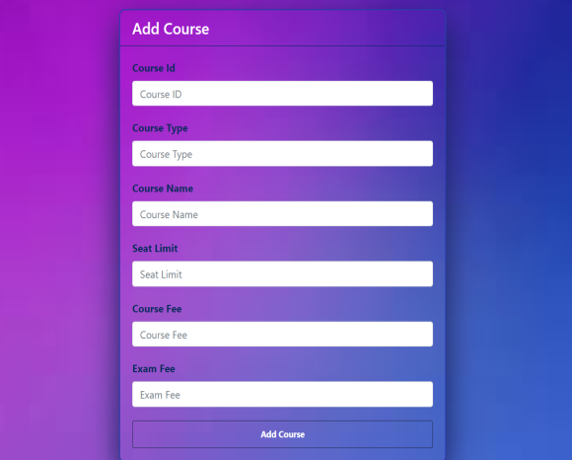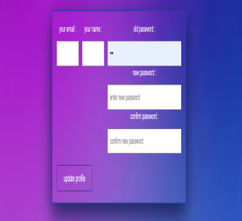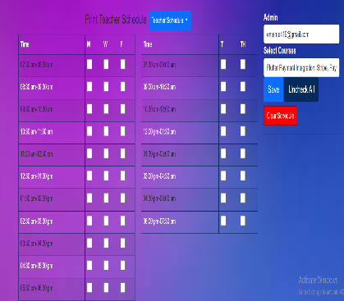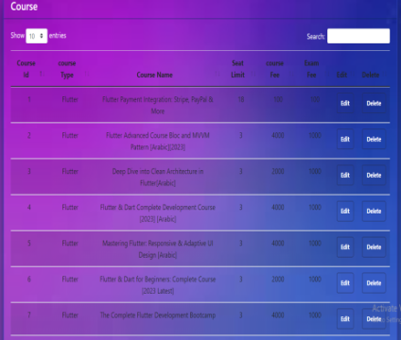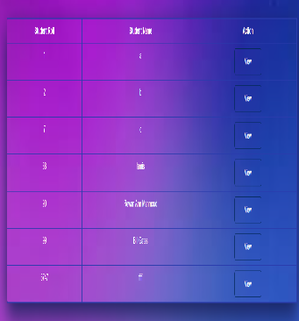

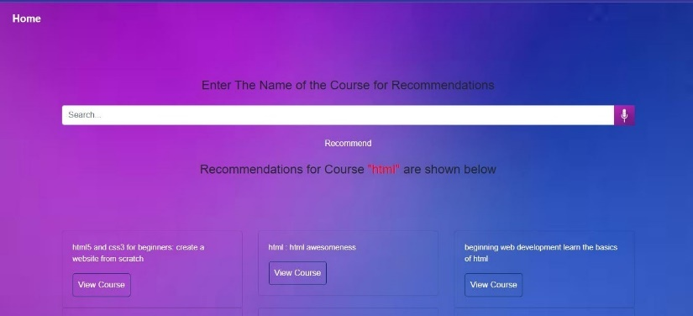

**5.Implementation Details**

**Course Recommendation**

**Ai**

**5.1Development environment setup:**

1. **Install Dependencies**: Navigate to the project directory and install the required dependencies. Typically, Python projects use a requirements.txt file to list dependencies (pip install -r requirements.txt)
2. **Configuration**: Review the configuration files provided in the repository and make any necessary adjustments according to your local development environment. This might include settings related to database connections, API keys, or file paths.
3. **Run the Application**: Depending on how the recommendation system is implemented, you may need to run a local development server.

* We can run this code with this state:

1. terminal:
2. cd C:\xampp\htdocs\CourseFlow\course-recommendation
3. python -m venv env
4. env\Scripts\activate
5. pip install -r requirements.txt
6. python.exe -m pip install --upgrade pip
7. pip install -r requirements.txt
8. pip install --upgrade Flask
9. pip install --upgrade Werkzeug
10. python app.py

**5.2Key algorithms or methodologies used**

* cosine similarity:

1. **Vector Representation**: Items or users are represented as vectors in a multi-dimensional space, where each dimension corresponds to a feature or attribute. For example, in a movie recommendation system, movies could be represented as vectors where each dimension represents a genre, director, actor, etc. Similarly, users could be represented as vectors where each dimension corresponds to their preferences for different genres or attributes.
2. **Cosine Calculation**: Cosine similarity is calculated by taking the dot product of the two vectors and dividing it by the product of their magnitudes. Mathematically, the cosine similarity between vectors AA and BB is given by:
   1. cosine_similarity

(A, B) =A⋅B∥A∥∥B∥cosine_similarity (A, B) =∥A∥∥B∥A⋅B​

* 1. where ⋅⋅ represents the dot product, and ∥A∥∥A∥ and ∥B∥∥B∥ represent the Euclidean magnitudes of vectors AA and BB, respectively.

1. **Interpretation**: The cosine similarity value ranges between -1 and 1. A value of 1 indicates that the vectors are perfectly aligned (i.e., they point in the same direction), while a value of -1 indicates perfect misalignment (i.e., they point in opposite directions). A value of 0 indicates orthogonality (i.e., the vectors are perpendicular to each other).
2. **Application in Recommendation Systems**: In recommendation systems, cosine similarity is used to measure the similarity between items or users based on their features or preferences. For example, to recommend movies to a user, the system can calculate the cosine similarity between the user's preference vector and the vectors representing different movies. The system then recommends movies with the highest cosine similarity scores.

* Linear Similarity:

1. "Linear similarity" may refer to the notion of similarity in a linear space or to similarity measures that utilize linear algebra concepts. However, it's not a standard term in the field of recommendation systems or similarity measures.
2. In recommendation systems, similarity measures like cosine similarity, Pearson correlation coefficient, and Jaccard similarity index are commonly used. These measures do involve linear algebra concepts, but they are not explicitly referred to as "linear similarity."

* TF-IDF (Term Frequency-Inverse Document Frequency); The TF-IDF (Term Frequency-Inverse Document Frequency) algorithm is a statistical measure used to evaluate the importance of a term within a document relative to a collection of documents, Used to vectorize the text data and represent each course title as a numerical feature vector. It is commonly used in natural language processing and information retrieval tasks, such as search engines, text mining, and recommendation systems.

**5.3Challenges faced and solutions**

* **Challenges:**

1. **Inefficient Course Scheduling**: Current course scheduling processes are often manual, time-consuming, and prone to errors. This inefficiency leads to suboptimal allocation of resources, conflicts in course timings, and difficulty in accommodating student preferences and constraints.
2. **Resource Allocation Constraints**: Educational institutions struggle to effectively allocate resources such as classrooms, laboratories, and faculty members to accommodate the diverse needs of different courses. Limited availability of resources and mismatches in supply and demand further exacerbate the problem.
3. **Lack of Transparency**: Students, faculty members, and administrators often face challenges in accessing transparent and up-to-date information regarding course offerings, prerequisites, availability, and scheduling changes. This lack of transparency can lead to confusion, dissatisfaction, and inefficiencies in academic planning.
4. **Inflexible Curriculum Management**: Existing systems may lack the flexibility to adapt to changing curriculum requirements, student interests, and industry demands. This rigidity hampers innovation impedes the introduction of new courses or program offerings and limits the institution's ability to stay relevant in a rapidly evolving educational landscape.
5. **Student Enrollment Challenges**: Difficulty in aligning course offerings with student preferences, academic requirements, and graduation timelines can result in enrollment bottlenecks, course shortages, and delays in degree completion. This can have negative implications for student retention, satisfaction, and overall academic success.

* **Solutions:**

1. **Inefficient Course Scheduling**:
   1. Solution: Implement an automated course scheduling system that utilizes algorithms to optimize course timetables based on various factors such as course prerequisites, faculty availability, room capacities, and student preferences.
   2. Use scheduling software that can generate conflict-free schedules, minimize gaps between classes, and accommodate individual student needs.
   3. Provide tools for students and faculty to input scheduling preferences and constraints, allowing the system to generate personalized schedules that meet their requirements.
   4. Regularly review and update schedules based on feedback and changing circumstances.
2. **Resource Allocation Constraints**:
   1. Solution: Develop a resource allocation system that tracks and manages the availability and utilization of classrooms, laboratories, equipment, and faculty members.
   2. Utilize predictive analytics and data-driven models to forecast resource demand and identify potential shortages or bottlenecks.
   3. Implement reservation systems or booking platforms to facilitate the efficient use of resources, allowing users to schedule rooms or equipment in advance.
   4. Explore options for sharing resources between departments or institutions to optimize utilization and reduce costs.
3. **Lack of Transparency**:
   1. Solution: Create a centralized information hub or online portal where students, faculty, and administrators can access up-to-date information on course offerings, prerequisites, availability, and scheduling changes.
   2. Ensure that the platform is user-friendly and provides intuitive navigation to easily find relevant information.
   3. Regularly update the platform with accurate data and timely notifications regarding any changes or updates.
   4. Provide training and support to users to familiarize them with the platform and encourage its use.
4. **Inflexible Curriculum Management**:
   1. Solution: Implement a flexible curriculum management system that allows for easy modification and customization of course offerings, program requirements, and elective options.
   2. Provide tools for curriculum planners and administrators to assess and update curriculum based on changing requirements, industry trends, and student feedback.
   3. Encourage interdisciplinary collaboration and innovation by offering cross-listed courses, interdisciplinary programs, and flexible degree pathways.
   4. Establish processes for regularly reviewing and revising curriculum to ensure relevance and alignment with academic standards and industry needs.
5. **Student Enrollment Challenges**:
   1. Solution: Develop a student enrollment system that provides personalized guidance and support to students throughout the enrollment process.
   2. Offer academic advising services to help students select appropriate courses, plan their academic paths, and navigate degree requirements.
   3. Implement waitlist management tools to efficiently handle enrollment bottlenecks and course shortages.
   4. Provide clear communication and guidance on course availability, prerequisites, and registration deadlines to minimize confusion and ensure timely enrollment.

______________________________________________

1. **Implementation Details** **Voice recognition**

**6.1 Development environment setup:**

**1. Install Dependencies**

Navigate to the project directory and install the required dependencies. Typically, Python projects use a requirements.txt file to list dependencies. Run the following command: (pip install -r requirements.txt)

**2. Configuration**

Review the configuration files provided in the repository and make any necessary adjustments according to your local development environment. This might include settings related to database connections, API keys, or file paths.

**3. Run the Application**

Depending on how the recommendation system is implemented, you may need to run a local development server.

* We can run this code with this state:

1. terminal:
2. cd C:\xampp\htdocs\CourseFlow\course-recommendation
3. python -m venv env
4. env\Scripts\activate
5. pip install -r requirements.txt
6. python endPointAPI.py

**6.2 Key algorithms or methodologies used**

* Speech-to-Text Integration:

1. Speech Recognition

* **API Integration:** AssemblyAI's API is used to convert spoken audio into text.
* **Initialization:** The assemblyai.Transcriber() class is instantiated to create a transcriber object.
* **Audio Source**: The audio file is captured from the user's microphone using the MediaRecorder API in JavaScript, saved as a WAV file, and sent to the Flask backend.
* **Audio Processing**: The Flask backend receives the audio file and uses the AssemblyAI API to process and transcribe the audio.
* **Text Conversion**: The transcribed text is obtained from AssemblyAI's API and further processed for corrections.

2. Flask Web Framework

* **Endpoint Definition**: A Flask application is created, and an endpoint is defined to handle audio data submission.
* **Running the Server**: The Flask app is configured to run on a specific port (5055).

3. Web Speech API

* **User Media Access**: The navigator.mediaDevices.getUserMedia() method is called to request access to the microphone.
* **MediaRecorder Object:** A new instance of MediaRecorder is created, which handles the recording of audio input.
* **Recognition Handling**: Event listeners are set up to handle the recording, stopping the recording, and sending the audio data to the backend for transcription.

**6.3 Challenges faced and solutions**

#### Challenges

1. **Accuracy and Recognition**:
   * **Challenge**: Ensuring accurate recognition of spoken words, especially with various accents, dialects, and speech patterns.
   * **Solution**: Utilize advanced speech recognition models trained on diverse datasets to improve accuracy. Implement continuous learning to adapt to new accents and speech patterns over time.
2. **Background Noise and Interference**:
   * **Challenge**: Speech input might be affected by background noise, making it difficult to accurately capture the intended query.
   * **Solution**: Incorporate noise-cancellation algorithms and filters to minimize the impact of background noise. Encourage users to use the feature in quieter environments when possible.
3. **Real-Time Processing**:
   * **Challenge**: Providing real-time transcription of speech to text without significant delays.
   * **Solution**: Use efficient, low-latency speech-to-text processing algorithms and leverage cloud computing resources to handle complex computations quickly.
4. **User Privacy and Data Security**:
   * **Challenge**: Ensuring the privacy and security of users' voice data.
   * **Solution**: Implement strong encryption protocols for data transmission and storage. Ensure compliance with data protection regulations and provide clear privacy policies to users.
5. **Handling Ambiguities and Errors**:
   * **Challenge**: Dealing with ambiguities or errors in speech recognition, such as homophones or mispronunciations.
   * **Solution**: Integrate context-aware algorithms that use surrounding text and previous user interactions to clarify ambiguities. Allow users to manually correct any errors in the transcribed text.
6. **User Adaptation and Training**:
   * **Challenge**: Encouraging users to adopt and effectively use the speech-to-text feature.
   * **Solution**: Provide tutorials and in-app guidance on how to use the feature effectively. Offer feedback mechanisms to continuously improve the user experience.

#### Solutions

1. **Advanced Speech Recognition Models**:
   * Implement state-of-the-art models such as Google's Speech-to-Text API, Amazon Transcribe, or custom-built models using frameworks like Deep Speech.
   * Regularly update and train these models with diverse datasets to improve accuracy.
2. **Noise Reduction Techniques**:
   * Use noise reduction algorithms and signal processing techniques to filter out background noise.
   * Implement features like automatic gain control and voice activity detection to enhance the clarity of speech input.
3. **Efficient Real-Time Processing**:
   * Optimize the processing pipeline to reduce latency. Use cloud services with high computational power for faster processing.
   * Employ techniques like streaming speech recognition to provide real-time feedback as the user speaks.
4. **Robust Security Measures**:
   * Ensure end-to-end encryption for all voice data.
   * Store data securely and anonymize it where possible to protect user identities.
   * Regularly audit security practices to comply with the latest standards and regulations.
5. **Context-Aware Error Handling**:
   * Develop algorithms that consider the context of the user's query to improve accuracy in handling ambiguities.
   * Provide options for users to correct transcriptions and learn from these corrections to improve future accuracy.
6. **User Education and Support**:
   * Create interactive guides and help sections to educate users on how to use the speech-to-text feature.
   * Collect user feedback on the functionality and make iterative improvements based on this feedback.

By addressing these challenges with robust solutions, the speech-to-text feature can significantly enhance the search experience, making it more accessible, efficient, and user-friendly.

**Chapter 7 Testing and Quality Assurance**

**7.1Testing strategies and methodologies:**

* **For course-recommendation**

1. **Unit Testing**:
   1. Test individual components and functions of the recommendation system, such as data preprocessing, feature extraction, similarity calculations, and recommendation algorithms.
   2. Mock external dependencies and data sources to isolate the units being tested.
   3. Use testing frameworks like PyTest or unittest to automate unit tests and ensure proper functioning of each unit.
2. **Integration Testing**:
   1. Test the integration between different modules and components of the recommendation system, including data pipelines, recommendation engines, and user interfaces.
   2. Validate the flow of data from data ingestion to recommendation generation and presentation.
   3. Use sample datasets or synthetic data to simulate real-world scenarios and verify that components interact correctly.
3. **End-to-End Testing**:
   1. Conduct end-to-end tests to validate the entire recommendation workflow, from user input to recommendation output.
   2. Simulate user interactions with the recommendation system through different channels (web, mobile app, API) and verify that recommendations are generated accurately and presented appropriately.
   3. Use test automation frameworks like Selenium or Puppeteer to automate end-to-end tests and ensure consistency across different environments.
4. **User Acceptance Testing (UAT)**:
   1. Involve real users or stakeholders in testing the recommendation system to gather feedback and assess user satisfaction.
   2. Define test scenarios and use cases that represent typical user interactions and preferences.
   3. Collect feedback on the relevance, diversity, and quality of recommendations and iterate based on user input.
5. **Performance Testing**:
   1. Evaluate the performance and scalability of the recommendation system under different load conditions.
   2. Measure response times, throughput, and resource utilization to ensure that the system can handle concurrent user requests and large datasets efficiently.
   3. Use load testing tools like Apache JMeter or Gatling to simulate heavy loads and identify performance bottlenecks.
6. **A/B Testing**:
   1. Conduct A/B tests to compare the effectiveness of different recommendation algorithms or configurations.
   2. Randomly divide users into control and experimental groups and expose them to different recommendation strategies.
   3. Measure key performance metrics such as click-through rates, conversion rates, and user engagement to determine the impact of changes on recommendation effectiveness.
7. **Security Testing**:
   1. Assess the security of the recommendation system to identify and mitigate potential vulnerabilities.
   2. Test for common security threats such as injection attacks, cross-site scripting (XSS), and sensitive data exposure.
   3. Use security testing tools like OWASP ZAP or Burp Suite to scan for security flaws and ensure compliance with security best practices.
8. **Regression Testing**:
   1. Continuously perform regression tests to ensure that new code changes or updates do not introduce regressions or break existing functionality.

* **For Speech Recognition**
  1. **Unit Testing:**
     + **API Integration:** Test the integration with AssemblyAI to ensure that audio files are correctly sent and transcriptions are received accurately.
     + **Text Processing:** Test the text processing steps, such as removing periods and correcting spelling using TextBlob.

**2. Integration Testing:**

* + - **Flask Endpoint:** Test the /process endpoint to ensure it handles file uploads, interacts with AssemblyAI, and processes the text correctly.
    - **Frontend and Backend Interaction:** Test the end-to-end flow from audio capture on the frontend to text display.

**3.** **End-to-End Testing**

* + - **Audio Capture to Text Display:** Verify that audio captured via the browser is correctly sent to the Flask server, processed, and the resulting text is displayed to the user.
    - **UI Testing:** Ensure the UI elements (buttons, input fields) work correctly and the user flow is smooth

**7.2Types of testing conducted (e.g., unit testing, integration testing):**

* **For course-recommendation**

1. **Unit Testing**:
   1. **Description**: Unit testing involves testing individual components or units of the recommendation system in isolation from the rest of the system.
   2. **Purpose**: Verify that each unit functions correctly and meets its requirements.
   3. **Examples**: Test data preprocessing functions, similarity calculation algorithms, and recommendation generation algorithms.
2. **Integration Testing**:
   1. **Description**: Integration testing focuses on testing the interactions between different modules or components of the recommendation system.
   2. **Purpose**: Ensure that components work together as expected and communicate effectively.
   3. **Examples**: Test data pipelines, recommendation engine integration with the database, and integration of recommendation algorithms with the user interface.
3. **End-to-End Testing**:
   1. **Description**: End-to-end testing validates the entire workflow of the recommendation system, from user input to recommendation output.
   2. **Purpose**: Verify that the recommendation system functions correctly in a real-world scenario and meets user expectations.
   3. **Examples**: Test user interactions with the system through different interfaces (web, mobile app, API), data ingestion, recommendation generation, and presentation of recommendations.
4. **User Acceptance Testing (UAT)**:
   1. **Description**: User acceptance testing involves testing the recommendation system with real users or stakeholders to gather feedback and assess user satisfaction.
   2. **Purpose**: Ensure that the recommendation system meets user needs, preferences, and usability requirements.
   3. **Examples**: Gather feedback on the relevance, diversity, and quality of recommendations from actual users and stakeholders.
5. **Performance Testing**:
   1. **Description**: Performance testing evaluates the performance and scalability of the recommendation system under different load conditions.
   2. **Purpose**: Measure response times, throughput, and resource utilization to ensure that the system can handle concurrent user requests and large datasets efficiently.
   3. **Examples**: Test response times of recommendation queries, measure system throughput under heavy load, and assess resource consumption.
6. **A/B Testing**:
   1. **Description**: A/B testing compares the effectiveness of different recommendation algorithms or configurations by exposing users to different versions of the system.
   2. **Purpose**: Determine which version of the recommendation system yields better results in terms of key performance metrics.
   3. **Examples**: Compare click-through rates, conversion rates, and user engagement between different recommendation strategies.
7. **Security Testing**:
   1. **Description**: Security testing assesses the security of the recommendation system to identify and mitigate potential vulnerabilities.
   2. **Purpose**: Ensure that the recommendation system is resistant to common security threats and complies with security best practices.
   3. **Examples**: Test for injection attacks, cross-site scripting (XSS), and sensitive data exposure vulnerabilities.
8. **Regression Testing**:
   1. **Description**: Regression testing verifies that new code changes or updates do not introduce regressions or break existing functionality.
   2. **Purpose**: Maintain the reliability and stability of the recommendation system over time.
   3. **Examples**: Verifying that the speech recognition functionality triggers appropriately when the user interacts with the voice recognition button.

* **For Speech Recognition**

1. **Unit Testing:**
2. **Description**: Unit testing involves testing individual components of the speech recognition system in isolation, ensuring they function as expected
3. **Purpose**: To verify the correctness of individual functions or methods responsible for speech recognition tasks.
4. **Examples**: Verify that the transcription function correctly transcribes audio files
5. **Integration Testing:**
6. **Description**: Integration testing involves testing how different components of the speech recognition system interact with each other.
7. **Purpose**: To ensure that multiple components integrate correctly and function together as a cohesive system..
8. **Examples**: Verify that the Flask endpoint /process correctly handles audio file uploads and responses.
9. **End-to-End Testing**
   * + **Description**: End-to-end testing involves testing the entire speech recognition system as a whole, from user input to output.
     + **Purpose**: To ensure that the entire speech recognition workflow functions correctly from a user's perspective.
     + **Examples**: Verify that the UI elements related to speech recognition, such as buttons and input fields, work as expected.

**7.3Results of testing and any bug fixes:**

* **For course-recommendation**

1. **Testing Results**:
   1. **Unit Testing**: Unit tests verify that individual components of the system work as expected. Passing unit tests indicate that these components meet their requirements and behave correctly.
   2. **Integration Testing**: Integration tests ensure that different modules or components of the system interact correctly. Successful integration tests demonstrate that these components integrate seamlessly and communicate effectively.
   3. **End-to-End Testing**: End-to-end tests validate the entire workflow of the system. Positive results from end-to-end testing indicate that the system functions correctly from user input to output.
   4. **User Acceptance Testing (UAT)**: UAT involves testing the system with real users to gather feedback and assess user satisfaction. Positive feedback and user acceptance suggest that the system meets user needs and expectations.
   5. **Performance Testing**: Performance tests measure the system's response times, throughput, and resource utilization under different load conditions. Favorable performance test results indicate that the system can handle expected user traffic efficiently.
   6. **A/B Testing**: A/B tests compare different versions of the system to determine which yields better results in terms of key performance metrics. Positive results from A/B testing inform decisions about system configuration and optimization.
   7. **Security Testing**: Security tests identify and address potential vulnerabilities in the system. Successful security testing ensures that the system is robust and resilient against common security threats.

* **For Speech Recognition**
  + - 1. **Testing Results**:
* **­­­­­­­­­­­­­­­­­­­­­­­­­­­­­­­Transcription Function:** Passed all test cases, accurately transcribing audio files.
* **Text Processing:** Functionality validated, handling punctuation removal and spelling correction effectively.

1. Integration Testing:
   * **Flask Endpoint:** Successfully handled audio file uploads and responses without errors.

**Chapter 8 Deployment**

**8.1 Deployment process:**

-The deployment process for a Course Flow web app typically involves several steps to ensure

that the application is successfully deployed and accessible to users. Below is a general outline of the deployment process:

* **Code Review and Testing:**
  + Before deployment, ensure that the codebase is thoroughly reviewed and tested to identify and fix any bugs or issues.
  + Conduct unit tests, integration tests, and possibly end-to-end tests to verify the functionality of the application.
* **Set Up Deployment Environment:**
  + Choose a suitable hosting environment for your web app. Common options include cloud platforms like AWS, Google Cloud Platform, or Microsoft Azure, or using a dedicated server.
  + Install any necessary software dependencies such as web servers, databases, and frameworks on the deployment environment.
* **Configuration:**
  + Configure the deployment environment to match the production environment, including settings for database connections, environment variables, and security configurations.
* **Build the Application:**
  + Compile or build the application into a deployable format (e.g., executable files, Docker containers, or static files).
  + Generate any necessary configuration files, such as environment-specific configuration files.
* **Database Migration (if needed):**
  + If there are any database schema changes or migrations, ensure that they are applied to the production database before deployment.
* **Deploy the Application:**
  + Upload the built application files to the deployment environment.
  + Configure the web server to serve the application.
  + Start the application server and ensure that it is running correctly.
* **Monitoring and Logging:**
  + Set up monitoring tools to track the performance and health of the deployed application.
  + Configure logging to capture errors and other important events for troubleshooting purposes.
* **Security Measures:**
  + Implement security measures such as firewalls, intrusion detection systems, and access controls to protect the deployed application from attacks.
  + Regularly update and patch the software and dependencies to address security vulnerabilities.
* **Load Testing and Performance Tuning (Optional):**
  + Conduct load testing to assess the application's performance under heavy traffic.
  + Optimize the application's performance by tuning database queries, optimizing code, and scaling resources as needed.
* **Deployment Verification:**
  + Once deployed, perform final verification checks to ensure that the application is accessible and functioning as expected.
  + Test various features and functionalities to ensure there are no issues in the production environment.
* **Rollback Plan:**
  + Have a rollback plan in place in case the deployment encounters critical issues or errors.
  + Document the steps needed to revert to the previous version of the application or configuration.
* **Continuous Deployment (Optional):**
  + Set up continuous deployment pipelines to automate the deployment process whenever new changes are pushed to the code repository.
  + This can streamline the deployment process and reduce the risk of human error.

By following these steps, you can effectively deploy a Course Flow web app and ensure that it is accessible and functional for your users.

**8.2 Hosting environment:**

The hosting environment refers to the infrastructure and services where your web application is deployed and made accessible to users over the internet. It typically includes:

**1. Servers:** These are physical or virtual machines that run the software needed to serve your web application to users. Servers can be managed by you (self-hosted) or provided by a hosting provider.

**2. Operating System:** The operating system installed on the server, such as Linux, Windows, or a specialized server OS, handles system-level operations and resource management.

**3. Web Server:** Software like Apache, Nginx, or Microsoft Internet Information Services (IIS) that receives requests from clients (web browsers) and serves web pages and other content in response.

**4. Database Server:** If your application requires a database to store and retrieve data, you'll need a database server like MySQL or Microsoft SQL Server.

**5. Networking Infrastructure:** This includes routers, switches, firewalls, and other networking hardware and software that enable communication between servers and clients while ensuring security and reliability.

**6. Storage:** Storage systems, such as hard disk drives (HDDs) or solid-state drives (SSDs), where your application's files, databases, and other data are stored.

**7. Security Measures:** Measures like firewalls, intrusion detection systems, encryption, and access controls are implemented to protect the hosting environment and your web application from unauthorized access and cyberattacks.

Hosting environments can vary depending on factors like scalability, performance requirements, budget, and technical expertise.

**8.3 Scalability considerations:**

Scalability considerations refer to factors that need to be taken into account when designing and deploying a web application to ensure that it can handle increased workload and user traffic as the application grows. Here are some key scalability considerations:

**1. Horizontal Scalability:** Design the application architecture to allow for horizontal scaling, where additional instances of the application can be added to distribute the load. This might involve using load balancers to evenly distribute incoming requests among multiple servers.

**2. Vertical Scalability:** Consider vertical scaling, which involves increasing the resources (such as CPU, memory, or storage) of individual servers to handle increased demand. This might require upgrading server hardware or switching to more powerful instances in a cloud environment.

**3. State Management:** Minimize reliance on server-side state to ensure that the application can scale horizontally. Use stateless components and externalize session state, caching, and other data storage to scalable external services or databases.

**4. Database Scaling:** Choose a scalable database solution and implement strategies such as sharding, replication, and partitioning to distribute the database workload across multiple servers.

**5. Caching:** Implement caching mechanisms at various levels of the application stack (e.g., database caching, in-memory caching, content delivery networks) to reduce the load on backend servers and improve response times for frequently accessed data.

**6. Asynchronous Processing:** Offload long-running or resource-intensive tasks to background processes or asynchronous workers to avoid blocking the main application thread. Use message queues, task queues, or job schedulers to manage asynchronous tasks.

**7. Microservices Architecture:** Decompose the application into smaller, loosely coupled services that can be independently deployed and scaled. This allows for more granular scalability and better isolation of failures.

**8. Auto-scaling:** Set up auto-scaling policies that automatically add or remove resources based on predefined metrics such as CPU utilization, memory usage, or incoming request rate. This ensures that the application can dynamically adapt to changes in demand.

**9. Performance Monitoring and Optimization:** Continuously monitor application performance and identify bottlenecks or areas for optimization. Use profiling tools, logging, and monitoring solutions to gain insights into application behavior and resource usage.

**10. Failure Handling and Redundancy:** Design the application with redundancy and fault tolerance in mind to minimize the impact of failures. Use techniques such as redundant components, failover mechanisms, and disaster recovery plans to ensure high availability.

By considering these scalability factors during the design and implementation of your web application, you can build a system that can efficiently grow and adapt to meet increasing demand and workload.

**Chapter 9 Maintenance and Support**

**9.1 Future plans for the application:**

**Reminders and notifications:**

Implementing personalized reminders and notifications can improve user engagement and retention. Users could receive notifications about upcoming course deadlines, new course releases in their preferred categories, or personalized recommendations based on their learning history and interests. This could be achieved by leveraging user data and implementing algorithms to tailor notifications to individual preferences.

**Face recognition:**

Incorporating face recognition technology can enhance security and user authentication processes. For instance, users could log in to their accounts using facial recognition instead of traditional username and password authentication. Additionally, face recognition could be utilized for identity verification in online exams or assessments, ensuring the integrity of the learning environment.

Each of these features has the potential to enhance the functionality and user experience of the Course Flow web app, making it more versatile, engaging, and user-friendly. However, it's important to consider factors such as user privacy, data security, and accessibility when implementing these technologies. Additionally, conducting user testing and gathering feedback throughout the development process can help ensure that these features meet the needs and preferences of the target audience.

**9.2 Potential updates or enhancements:**

Potential updates or enhancements for the Course Flow web app could include:

**1. Advanced Search and Filtering:** Implementing advanced search and filtering options to allow users to refine their course searches based on criteria such as price range and course duration

**2. Social Learning Features:** Introducing social learning features such as user profiles, activity feeds, follower networks, and messaging capabilities to foster community interaction, collaboration, and peer support among learners.

**3. Virtual Labs or Simulations:** Integrating virtual labs or simulations for hands-on learning experiences in technical or practical subjects such as programming, engineering, or scientific disciplines, allowing learners to apply theoretical knowledge in a simulated environment.

**4. Accessibility Improvements:** Enhancing accessibility features such as screen reader compatibility, keyboard navigation, alt text for images, and color contrast adjustments to ensure that the platform is usable and inclusive for learners with disabilities.

These updates and enhancements can enrich the Course Flow web app's functionality, user experience, and value proposition, making it a more compelling and effective platform for online learning. Prioritizing updates based on user feedback, market trends, and business goals can ensure that the platform continues to evolve and meet the evolving needs of learners and educators.

**Chapter 10**

**User Documentation**

**10.1 FAQs:**

**1.What is the Course Flow web app?**

 The Course Flow web app is an online platform designed to help educational institutions, universities, or training centers manage and display their course schedules efficiently. It provides an intuitive interface for both administrators and students to access and interact with schedule information.

**2.What inspired the development of the Course Flow web app?**

 The Course Flow web app draws inspiration from popular online learning platforms like Udacity, Coursera, edX, and Khan Academy. These platforms have revolutionized education delivery, and Course Flow aims to streamline course scheduling and organization similarly.

**3.What problems does Course Flow aim to solve?**

 Course Flow addresses common challenges faced by educational institutions, including inefficiencies in course scheduling, resource allocation, and lack of transparency in current systems. It aims to optimize course management, enhance user experience, and improve overall efficiency.

**4.What are the key features of Course Flow?**

**Some key features include:**

   ·Integrated Course Management Platform

   ·Scheduling and Resource Allocation

   ·User-Friendly Interface

   ·AI Course Recommendation System

. Speech-to-Text Search for Courses

   ·Data Analytics and Reporting

   ·Scalability and Future-Proofing

   ·Security and Privacy measures

**5.How does the AI Course Recommendation System work?**

 The AI Course Recommendation System utilizes machine learning algorithms to recommend courses based on user preferences and search queries. It analyzes course titles, descriptions, and associated keywords to suggest relevant courses, enhancing the user's learning experience.

**6. How does the Speech-to-Text Search for Courses feature work?**

The Speech-to-Text Search for Courses feature allows users to search for courses using voice commands.

By clicking the voice recognition button on the web app, the system captures the user's speech using the browser's microphone access.

The recorded audio is then sent to the server where it is processed using AssemblyAI's speech-to-text API to convert the audio into text.

This transcribed text is subsequently used to perform a course search within the platform, enhancing accessibility and user-friendliness.

**7.What data sources and preprocessing techniques are used in Course Flow?**

Course Flow utilizes data from Udemy, a massive online open course (MOOC) platform, containing information about course titles, subjects, categories, pricing, subscribers, and more. Text preprocessing techniques such as removing stop words, tokenization, and TF-IDF vectorization are employed for data cleaning and analysis.

**8.What tools and technologies are used in developing Course Flow?**

Course Flow is developed using technologies such as XAMPP, PHP, Figma, Visual Studio Code, Flask and Python. These tools enable efficient web development, database management, and user interface design.

**9.What are some potential future enhancements for Course Flow?**

Future enhancements may include implementing personalized reminders and notifications and integrating face recognition, and continuously improving the user experience based on feedback and evolving technologies.

**11.Conclusion**

**11.1 Achievements:**

-In the development of the Course Schedule & Recommendation System, several significant achievements have been made, paving the way for efficient course management and enhancing user experience. Here are some key achievements:

1. **User-Friendly Interface:**
   * Developed an intuitive and easy-to-navigate interface for both administrators and students, ensuring a smooth user experience throughout the platform.
2. **Efficient Course Management:**
   * Implemented a robust course management system that enables educational institutions to efficiently organize, schedule, and display their courses.
3. **AI Course Recommendation:**
   * Integrated AI-driven course recommendation feature, leveraging machine learning algorithms to suggest relevant courses to users based on their interests and search queries.
4. **Speech-to-Text Search for Courses:**

* Added a speech-to-text feature allowing users to search for courses using voice commands, enhancing accessibility and convenience.

1. **Data Analytics and Reporting:**
   * Conducted extensive exploratory data analysis (EDA) to gain insights into course data, including distribution, popularity, correlation analysis, and pricing trends.
2. **Security and Privacy:**
   * Ensured data security and privacy by implementing appropriate measures to protect user information and sensitive data within the platform.
3. **Technological Stack:**
   * Utilized a diverse set of technologies and tools including XAMPP, PHP, Figma, Visual Studio Code, and Python to develop and deploy the web application.
4. **Future Enhancements:**
   * Outlined potential future enhancements including incorporating personalized reminders and notifications and integrating advanced features such as face recognition.

- By accomplishing these milestones, the Course Flow web application has successfully addressed the challenges in course scheduling and management, providing a valuable solution for educational institutions, universities, and training centers. The project demonstrates innovation, technical expertise, and a commitment to enhancing the educational experience for both administrators and students.

**11.2 Lessons Learned**

1. **User-Centric Design**:

* Throughout the development process, it became evident that prioritizing user experience was paramount. Features such as intuitive navigation, clear information presentation, and streamlined processes greatly enhanced user satisfaction.

1. **Flexibility and Scalability**:

* Building the system with scalability in mind allowed for future expansion and adaptation to changing needs. By designing modular components and utilizing scalable technologies, the platform can accommodate growth and additional functionalities.

1. **Integration Challenges**:

* Integrating diverse technologies and tools, such as Xampp, PHP, Figma, Visual Studio Code, and Python, presented certain challenges. Ensuring seamless integration and compatibility required thorough testing and troubleshooting.

1. **Data Quality and Preprocessing**:

* Working with real-world data from Udemy posed challenges in terms of data quality and preprocessing. Implementing robust data cleaning and preprocessing pipelines was essential for accurate analysis and recommendation generation.

1. **Algorithm Selection and Optimization**:

* Selecting appropriate algorithms, such as TF-IDF for text vectorization and cosine similarity for recommendation generation, required careful consideration. Optimizing these algorithms for performance and accuracy involved experimentation and tuning parameters.

1. **Speech Recognition Integration:**

* Implementing the speech-to-text feature introduced challenges related to speech recognition accuracy and user interface design. Addressing issues like noise handling and real-time processing was critical for providing a seamless user experience.

1. **Continuous Improvement**:

* Recognizing that software development is an iterative process, ongoing feedback loops and continuous improvement cycles were essential. Incorporating user feedback, addressing issues, and implementing enhancements ensured the platform's relevance and effectiveness over time.

1. **Security and Privacy Concerns**:

* Safeguarding user data and ensuring platform security were critical considerations. Implementing robust security measures, such as encryption, secure authentication mechanisms, and data access controls, helped mitigate potential risks and ensure user privacy.

1. **Cross-Platform Compatibility**:

* Ensuring compatibility across different devices and platforms required comprehensive testing and optimization. Adhering to industry standards and best practices for web development facilitated seamless user experiences across various devices and browsers.

1. **Collaboration and Communication**:

* Effective collaboration and communication among team members were essential for project success. Regular meetings, clear documentation, and utilizing collaboration tools facilitated smooth coordination and alignment of goals throughout the development lifecycle.

1. **Adaptability to Emerging Technologies**:

* Remaining abreast of emerging technologies and trends in the education and technology sectors enabled the project to stay relevant and innovative. Being open to integrating new technologies and adapting to evolving user needs is crucial for long-term sustainability and success.

-By reflecting on these lessons learned, future iterations of the project can continue to evolve and improve, ultimately delivering greater value to users and stakeholders.

**12.References**

**12.1** **List of resources used:**

**Online Learning Platforms:**

1. **Udemy**
   * A leading online learning platform offering a wide range of courses in various subjects.
2. **Coursera**
   * An online platform providing courses, specializations, and degrees from top universities and institutions.
3. **Edx**
   * Offers online courses from universities like Harvard, MIT, and Berkeley, covering diverse subjects.
4. **Khan Academy**
   * Provides free online courses, lessons, and practice in various subjects, from mathematics to history.
5. **Udacity**
   * Offers online courses and nanodegree programs in technology-related fields such as programming, data science, and AI.

**Research Papers:**

1. **AN ONLINE WEB COURSE ENVIRONMENT AND ITS APPLICATION**
   * Authors: Cíntia Borges Margi, Oscar Dantas Vilcachagua, Itana Stiubiener, Regina Melo Silveira, Graça Bressan, Wilson Vicente Ruggiero
2. **AN EVALUATION OF LEARNING IN AN ONLINE PROJECT-BASED WEB APPLICATION DESIGN AND DEVELOPMENT COURSE**
   * Author: Heidi J. C. Ellis
   * Affiliation: Computer Science Department, Trinity College

**13.Appendices**

**13.1 Additional Technical Details:**

1. **Database Management**:
   * **SQL Databases**: The system employs a robust database management system to efficiently store and retrieve course-related information. Utilizing SQL databases ensures data integrity, reliability, and scalability as the platform grows.
   * **Normalized Database Schemas:** Implementation of normalized database schemas ensures efficient data storage, minimizing redundancy and enhancing data consistency.
2. **Server-Side Development**:
   * **PHP:** is utilized for server-side scripting, facilitating dynamic content generation and interaction with the database.
   * **XAMPP:** serves as the local server environment, providing Apache for web server functionality, MySQL for database management, and PHP for server-side scripting.
3. **Frontend Development**:
   * **Visual Studio code:** is utilized for frontend development, enabling the creation of responsive and visually appealing user interfaces.
   * **HTML, CSS, and JavaScript:** are employed for front-end programming, ensuring cross-browser compatibility and an engaging user experience.
4. **User Authentication and Authorization**:
   * **Secure Authentication:** Secure user authentication mechanisms are implemented to safeguard user accounts and sensitive information. Password hashing and salting techniques are employed to enhance security.
   * **Role-based access control (RBAC):** ensures that users are granted appropriate permissions based on their roles, such as student or administrator.
5. **API Integration**:
   * **Python and Flask:** Python, along with Flask, is utilized to develop APIs for integrating AI-driven functionalities such as machine learning-based course recommendations.
   * **RESTful API architecture:** enables seamless communication between different components of the system, allowing for extensibility and interoperability.
   * **AssemblyAI for Speech-to-Text:** AssemblyAI is utilized for speech recognition capabilities, converting audio to text. It's integrated into the system to enhance the speech-to-text feature. Source: AssemblyAI Documentation
6. **Speech to Text Feature**
   * **Speech Recognition Library:** The speech-to-text feature is implemented using the Speech Recognition library in Python, which supports several engines and APIs. [Source: Speech Recognition Documentation](https://pypi.org/project/SpeechRecognition/)
   * **Flask:** is used to manage the backend processing of audio files. The audio input is captured through a web interface.

* **Integration:** The implementation involves capturing audio from the user through a web interface, sending it to the backend for processing using Flask and Assembly AI, and then utilizing the transcribed text for various functionalities such as course searches.

1. • **UI/UX Design**:
   * **Figma:** is utilized for UI/UX design, enabling collaborative design processes and iterative prototyping. It is a web-based graphics editing and user interface design app. [Source: Figma Official Site](https://www.figma.com/)
   * **Responsive design principles:** are followed to ensure optimal user experience across various devices and screen sizes.

**13.2 Diagrams**

* 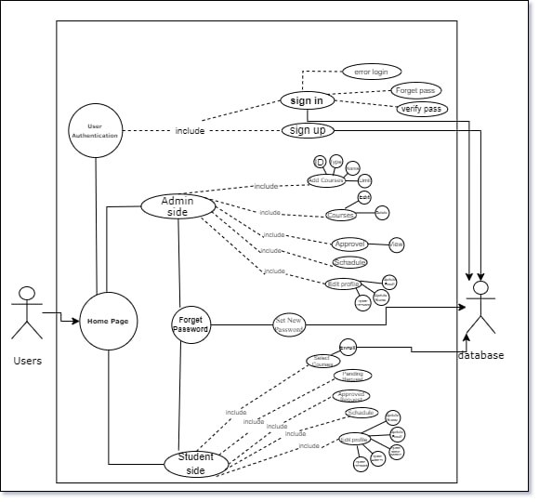**Use Case Diagram:**
* 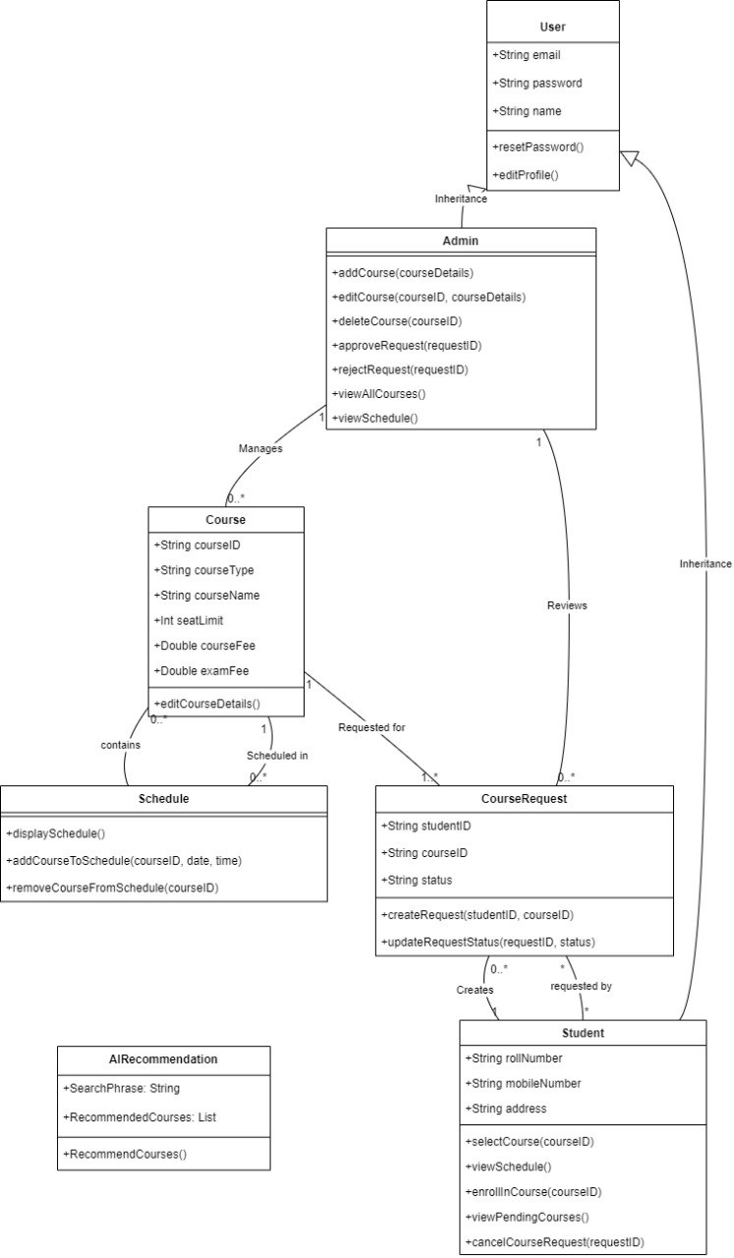**Class Diagram:**
* 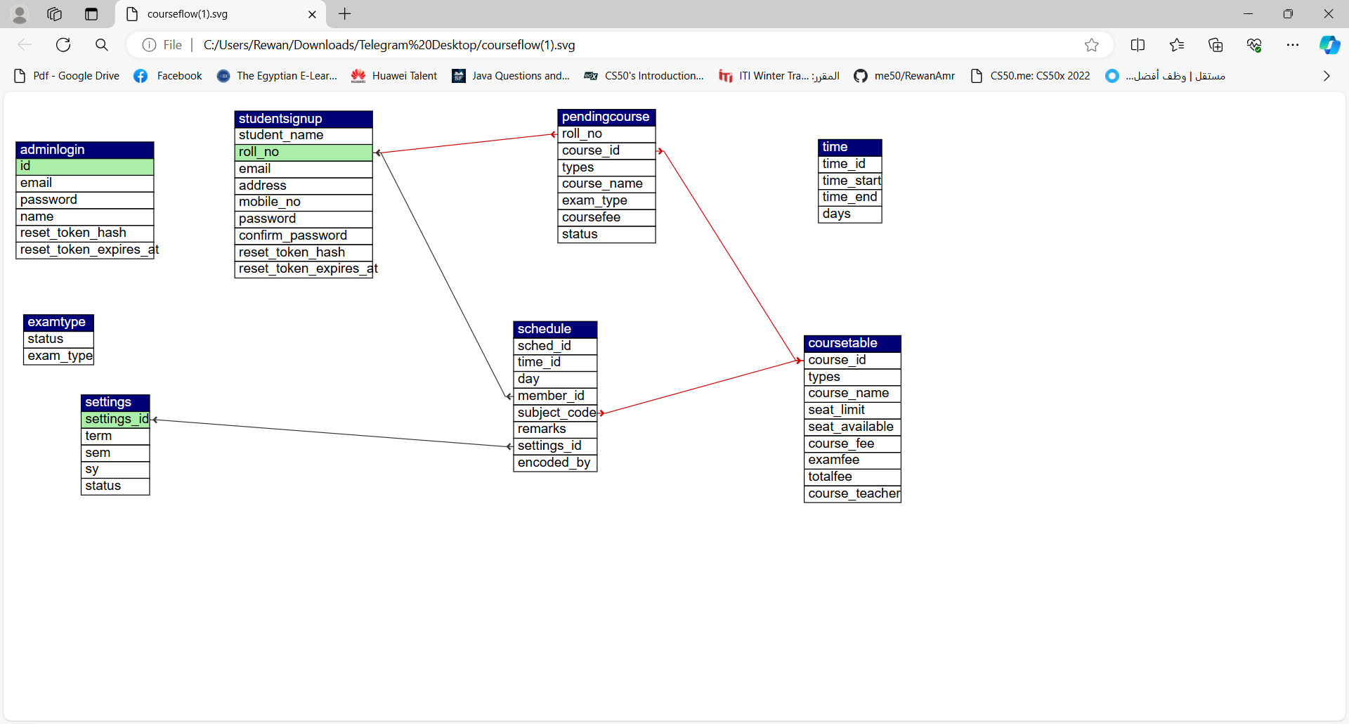**ERD:**
* 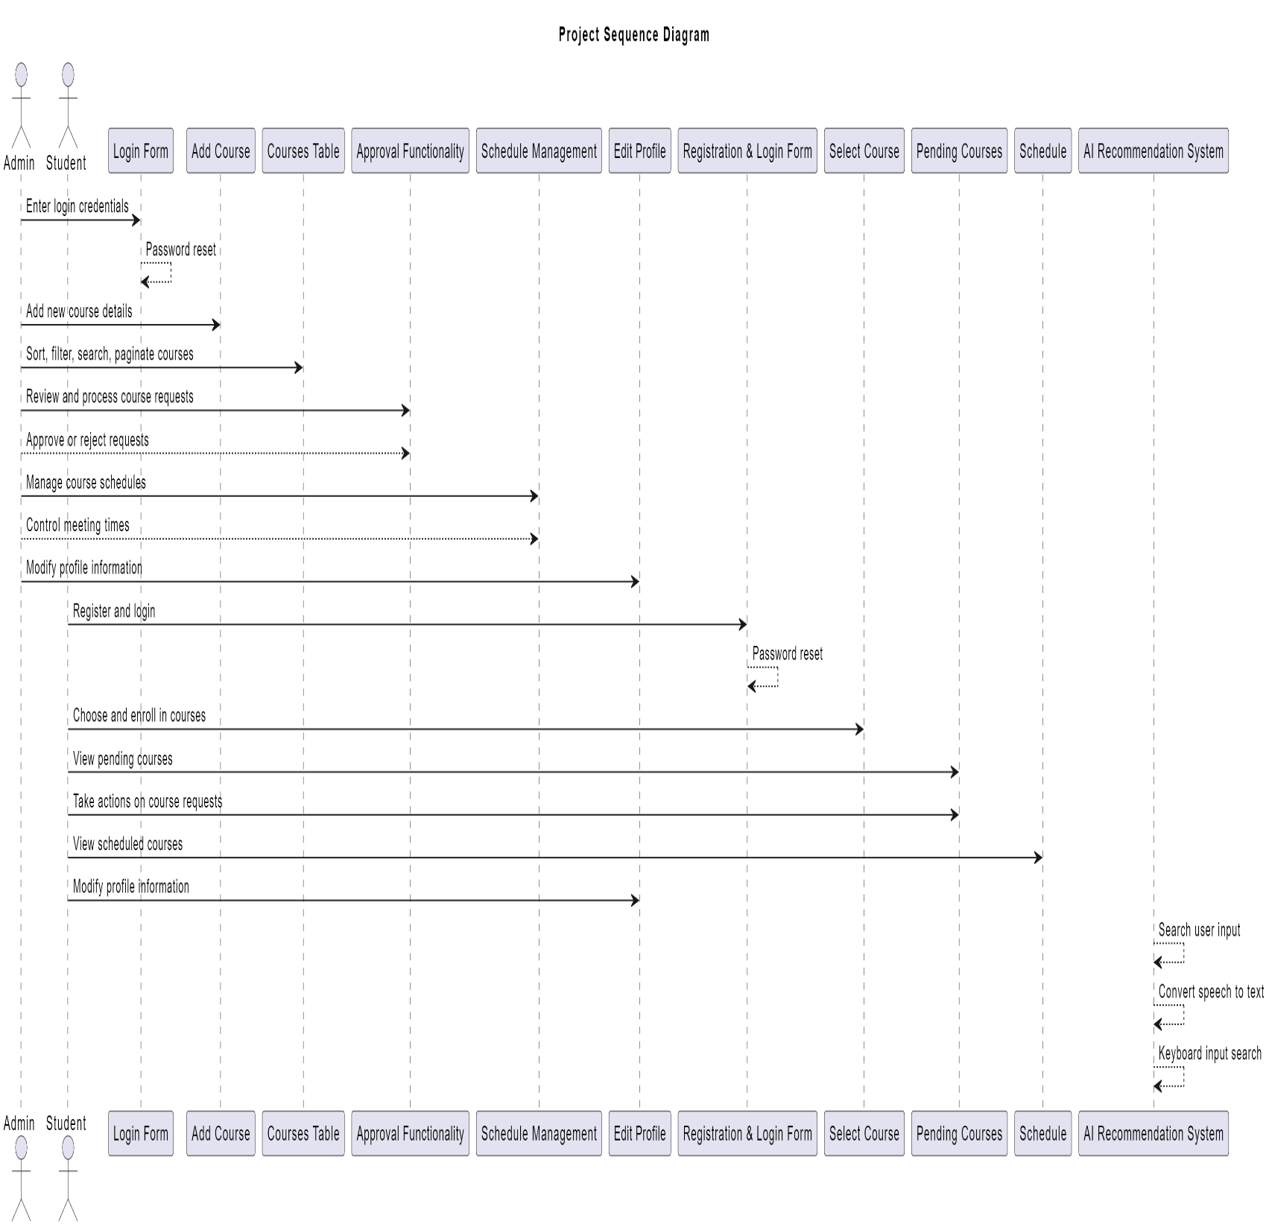**Sequence Diagram:**
* 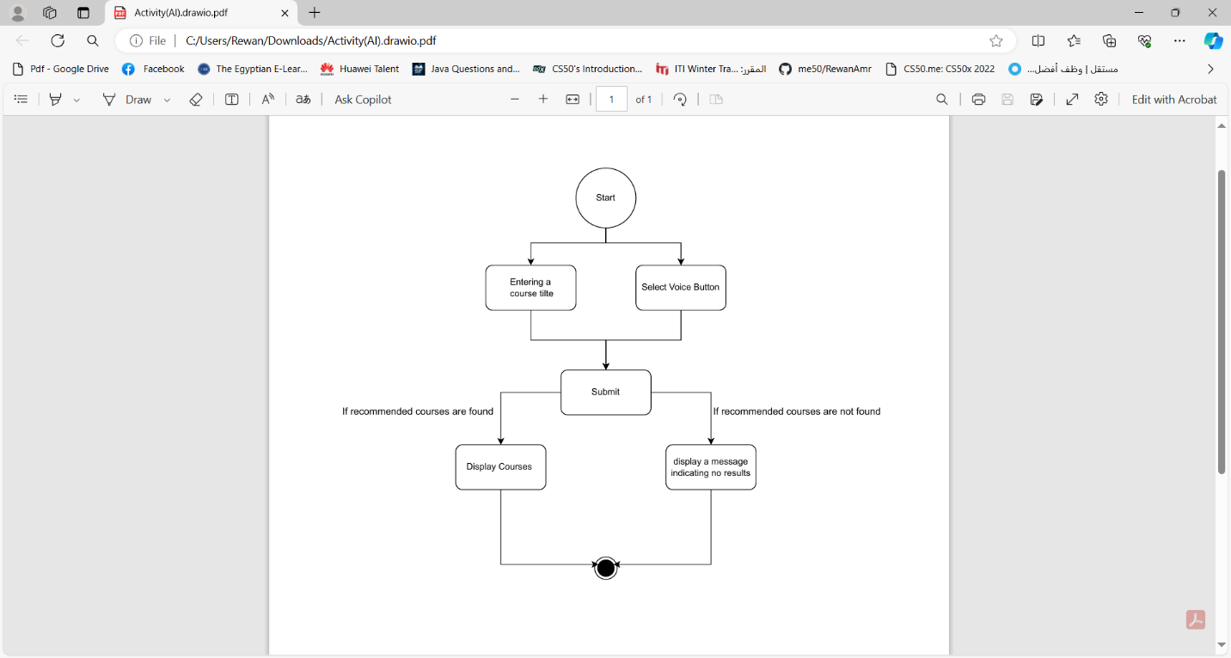**Activity AI**
* **Activity Admin Side:**
* 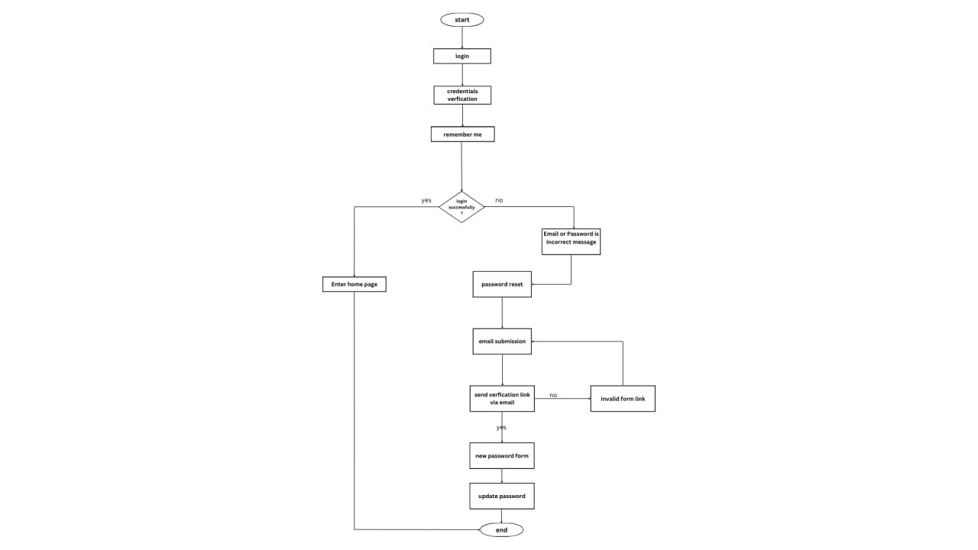 **1. Login**

**2.Add Course**

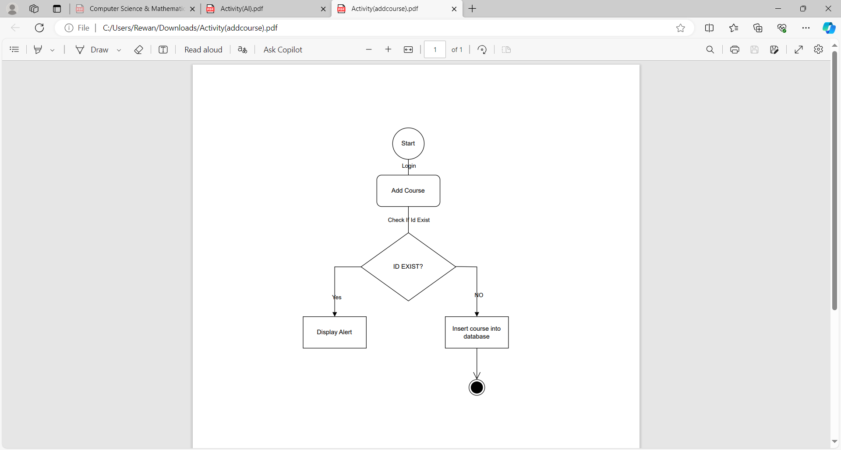

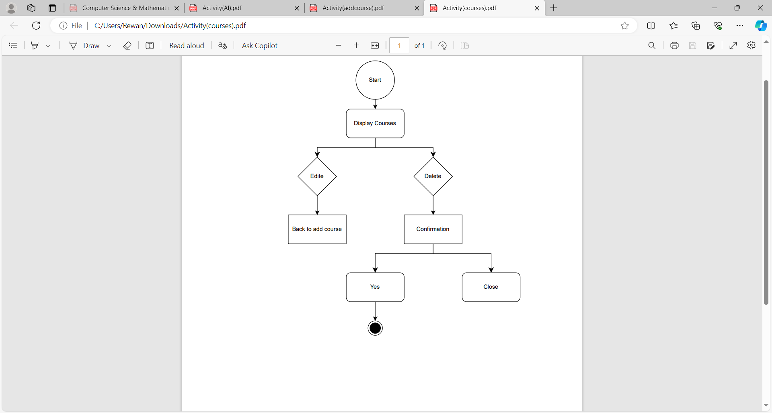**3.Courses**

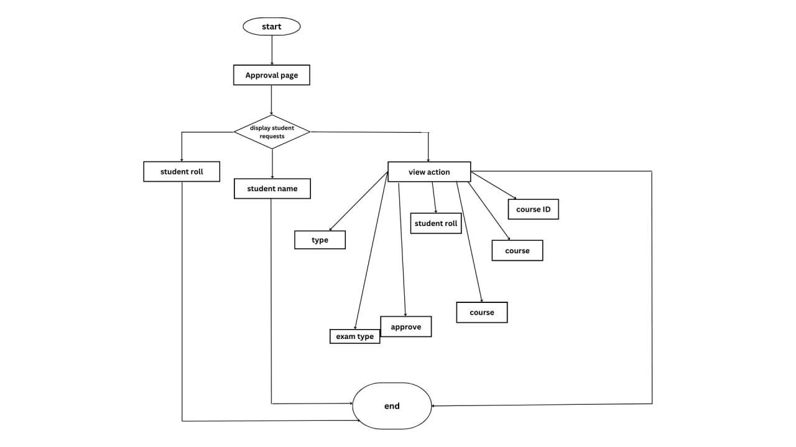**4.Approval**

**5.Schedule**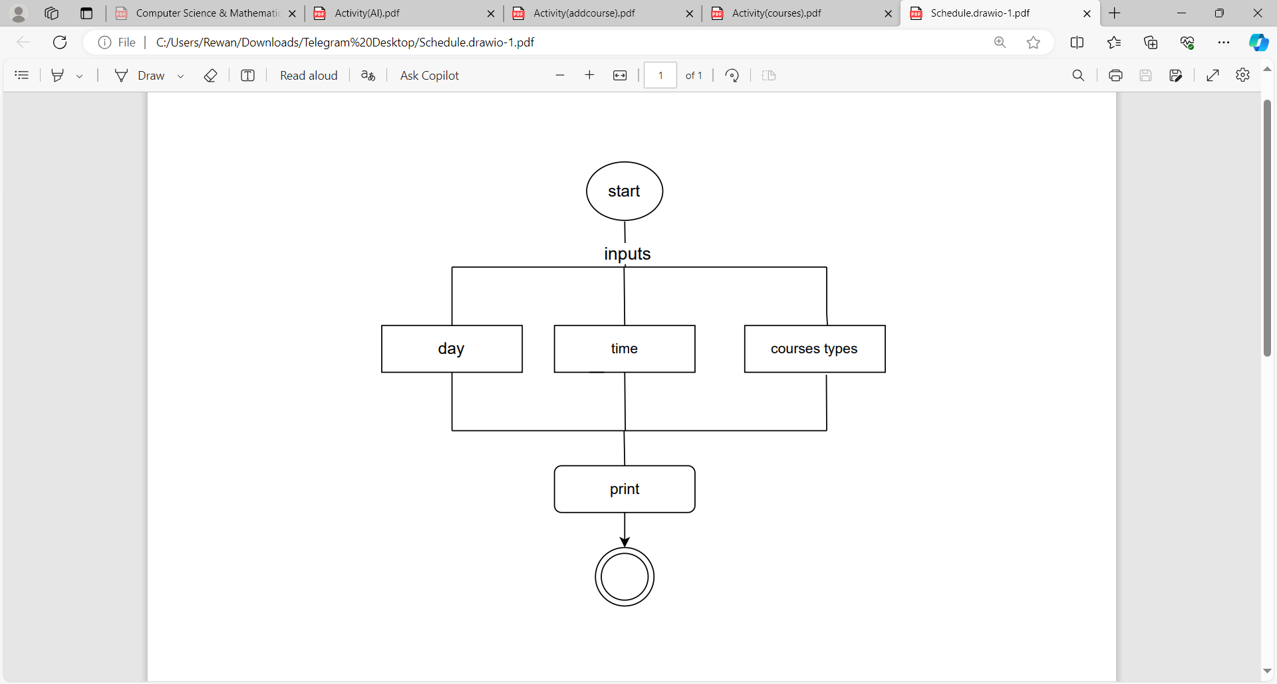

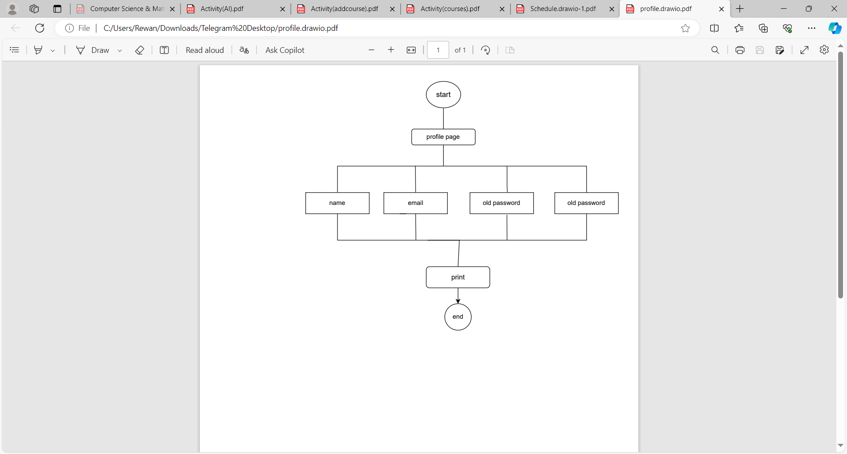**6.Profile**

**Activity Student Side:**

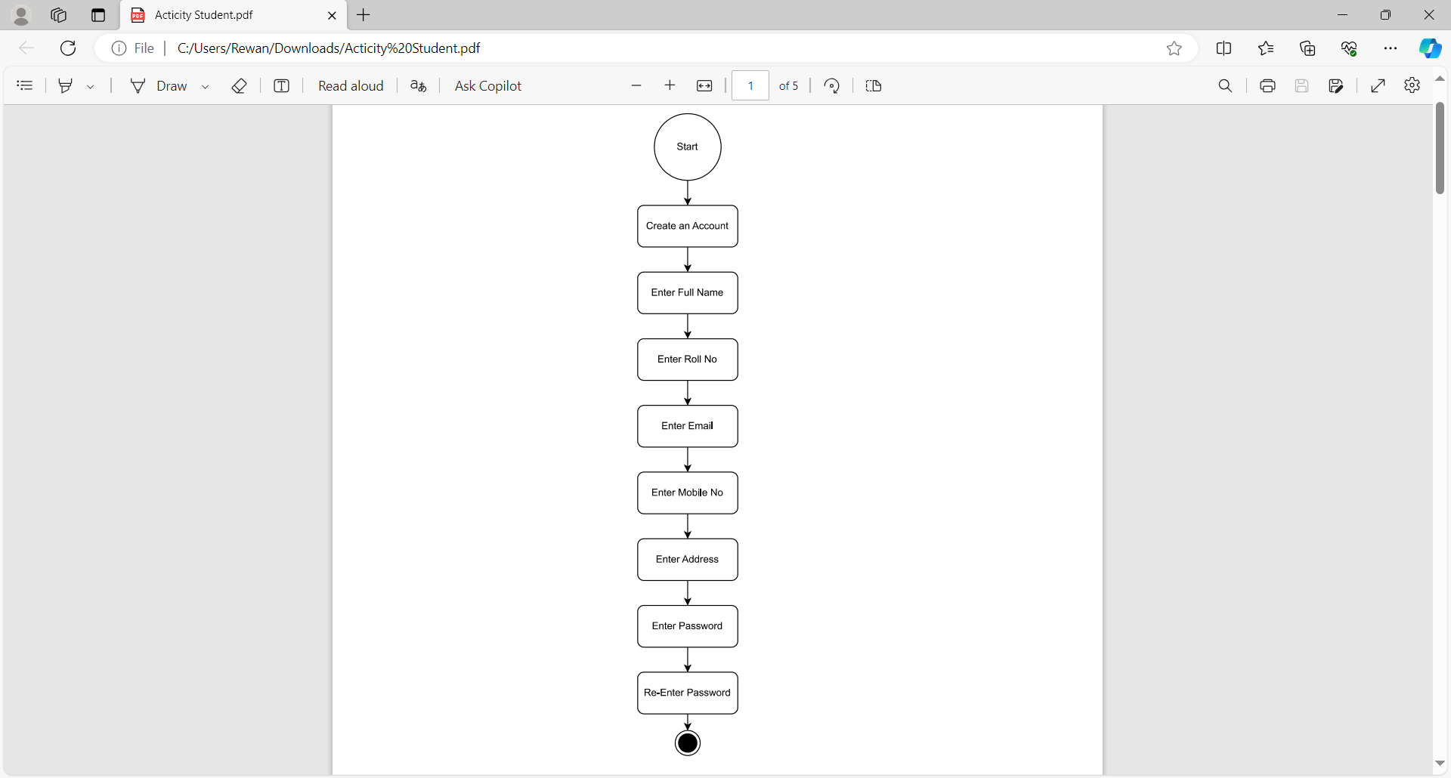**1.Registration**

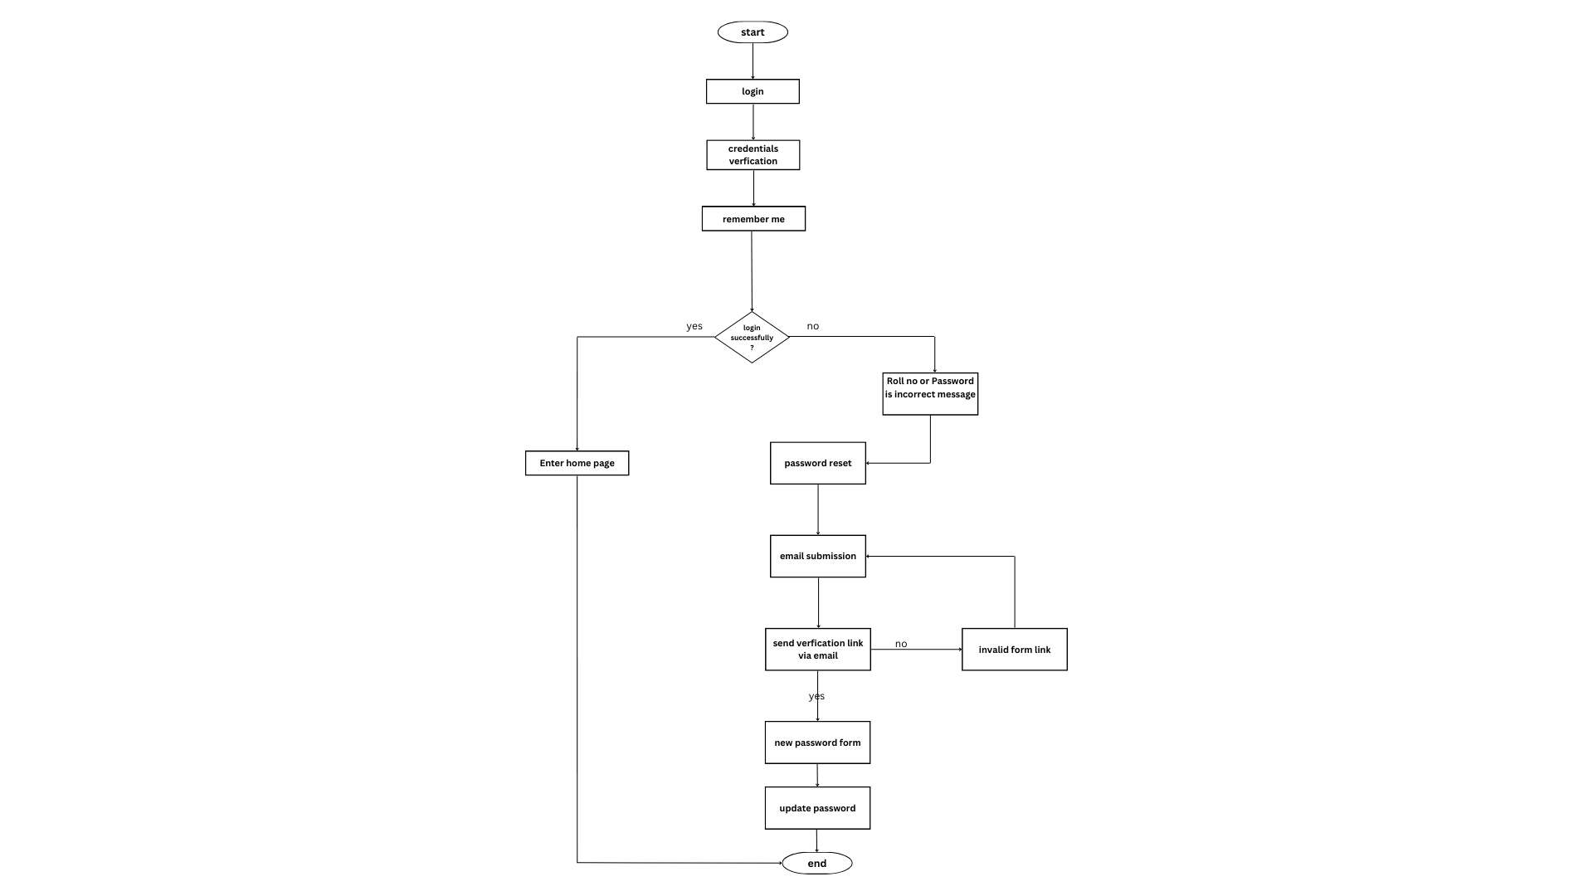**2.Login**

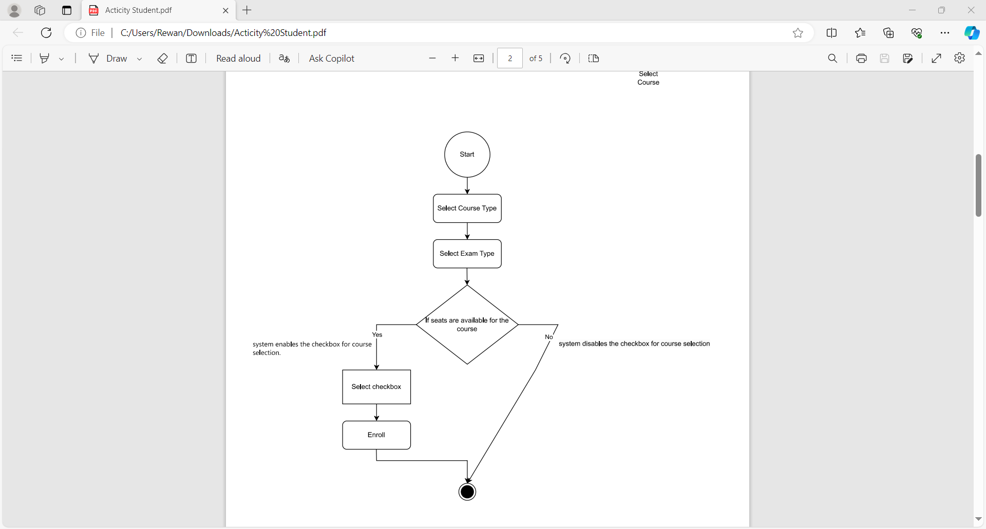**3.Select Course**

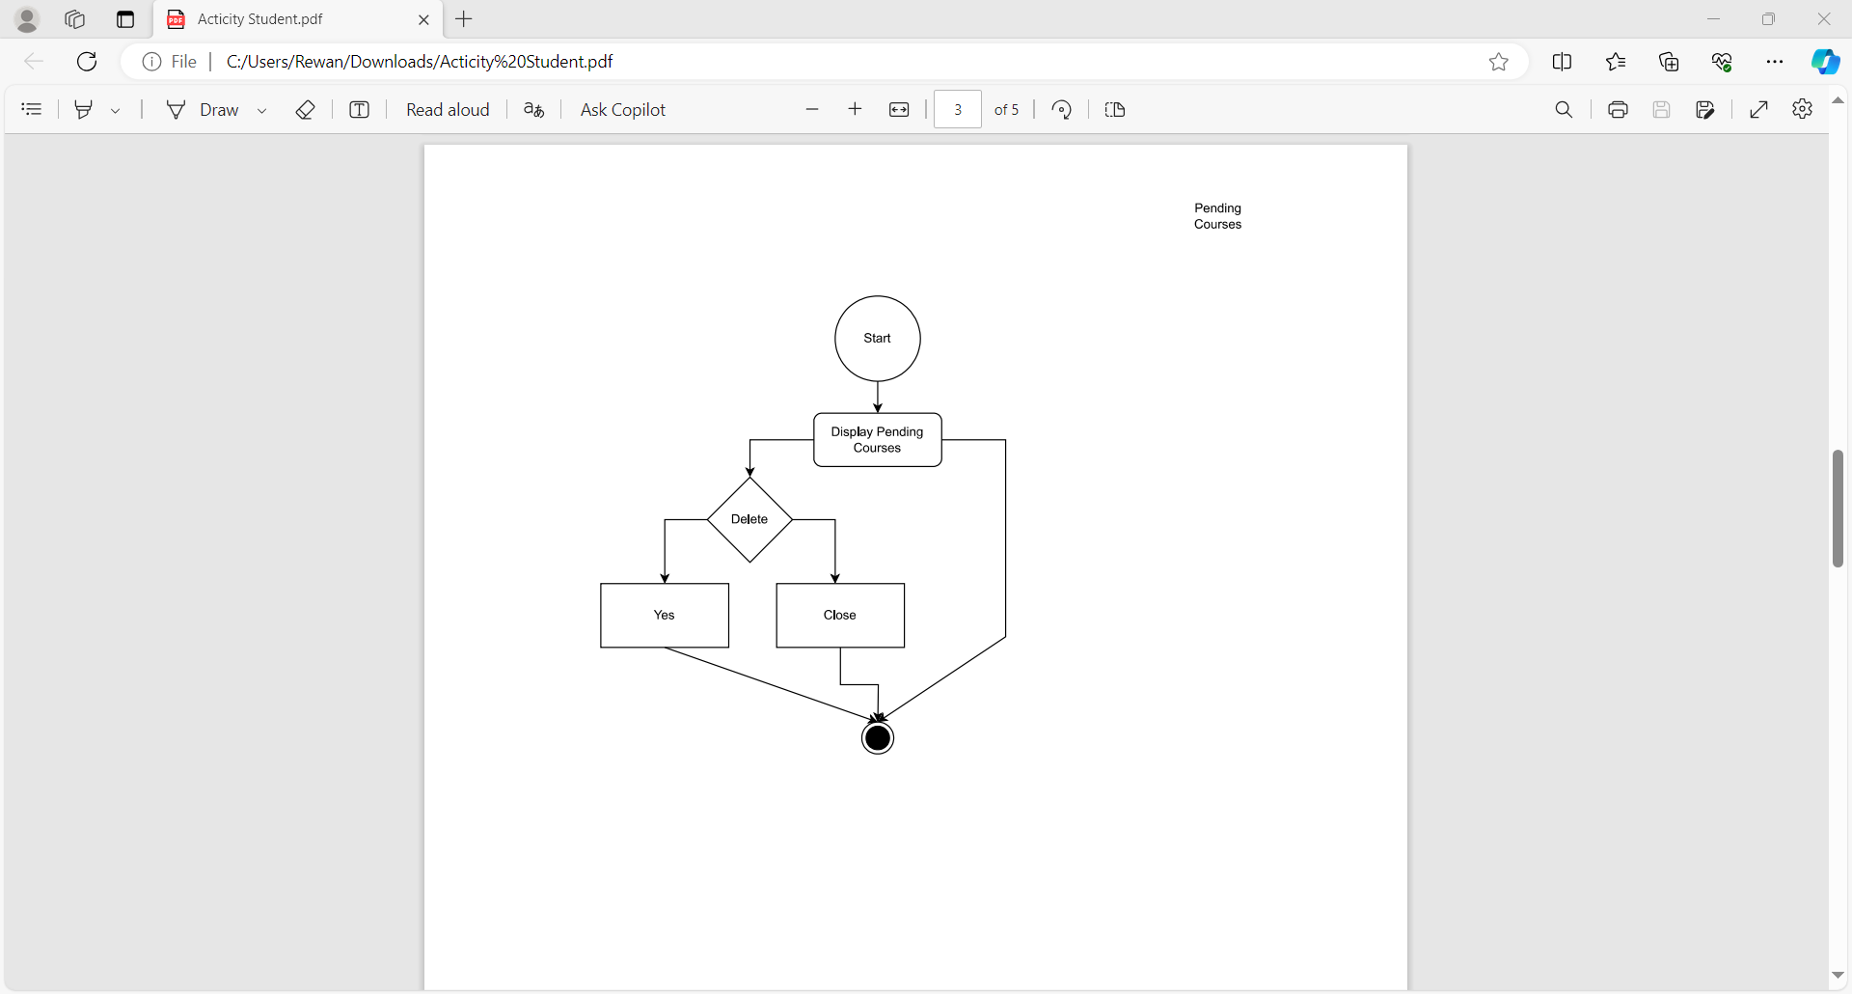**4.Pending Courses**

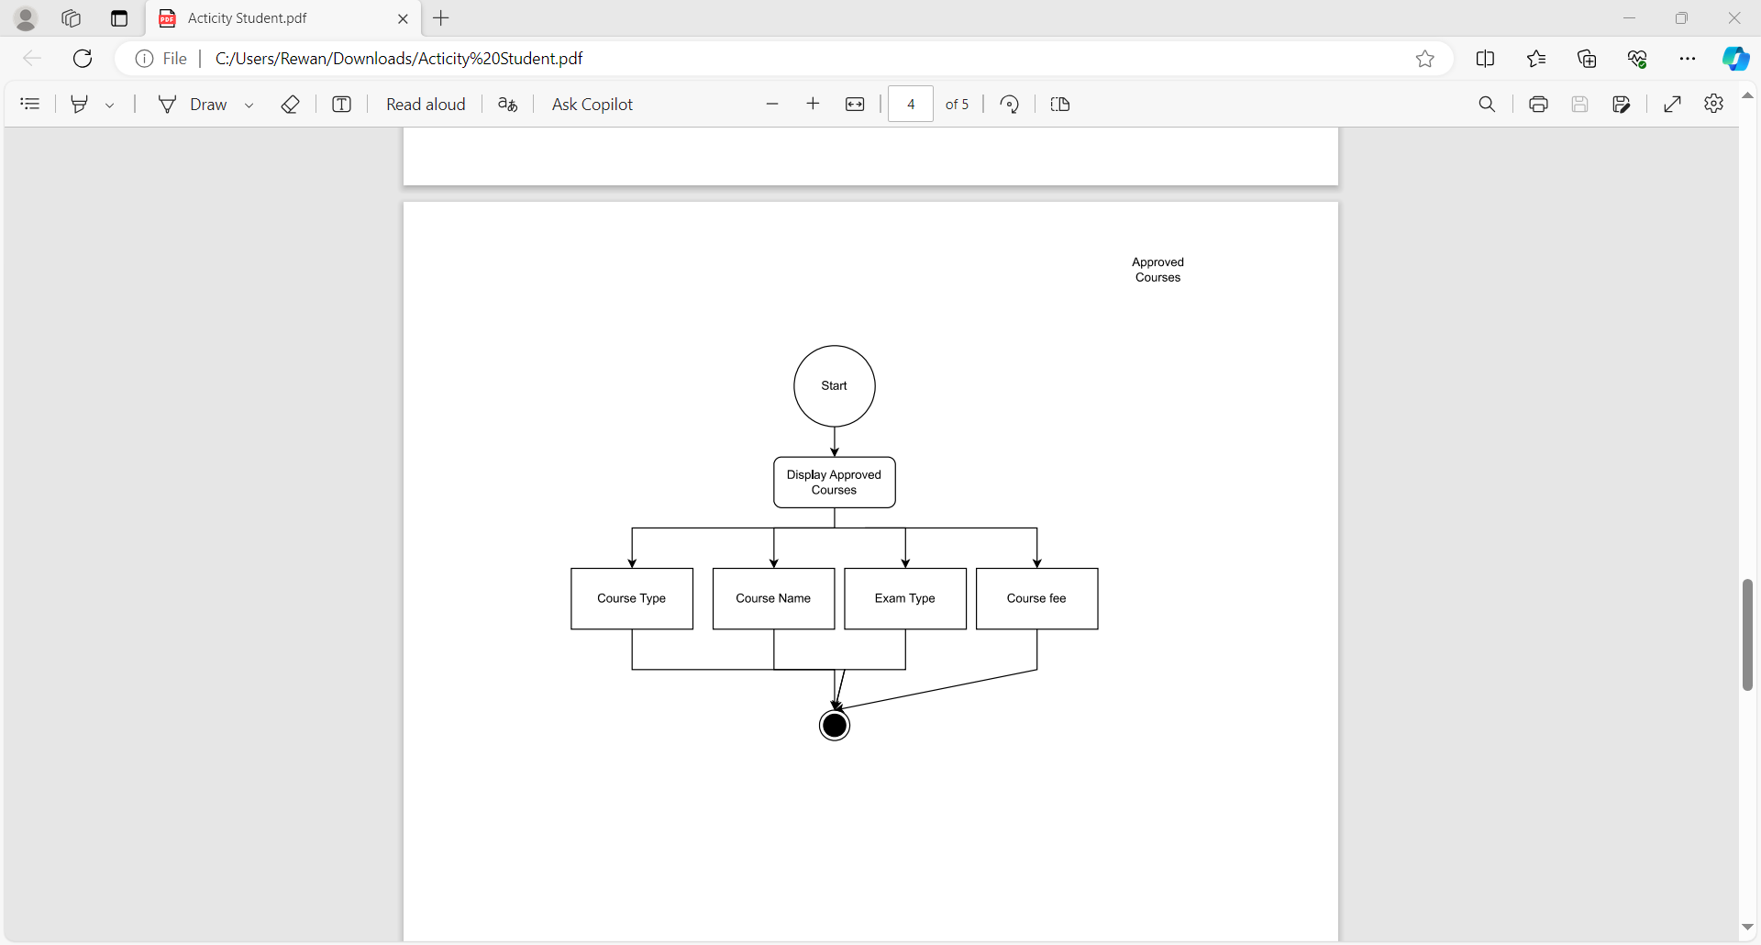**5.Approved Courses**

**6. Schedule**

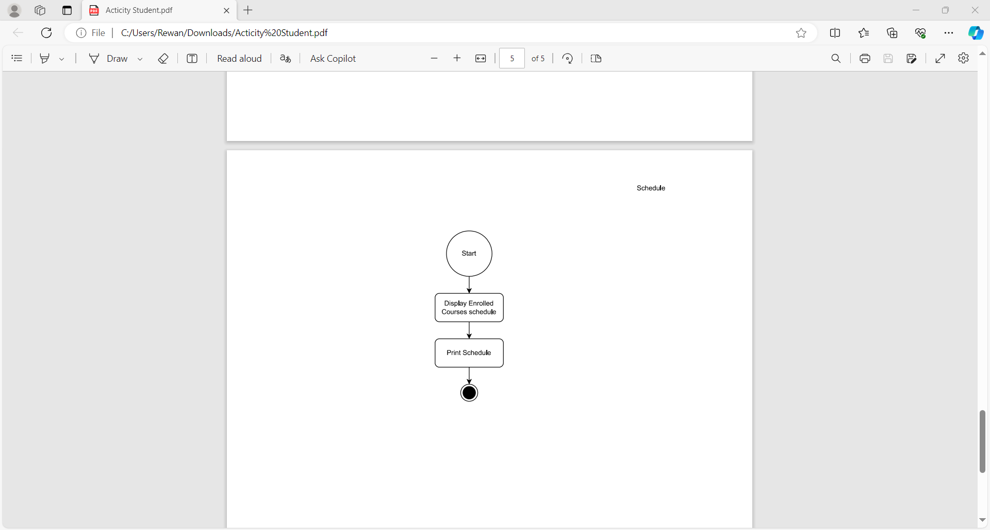

**7.Profile**

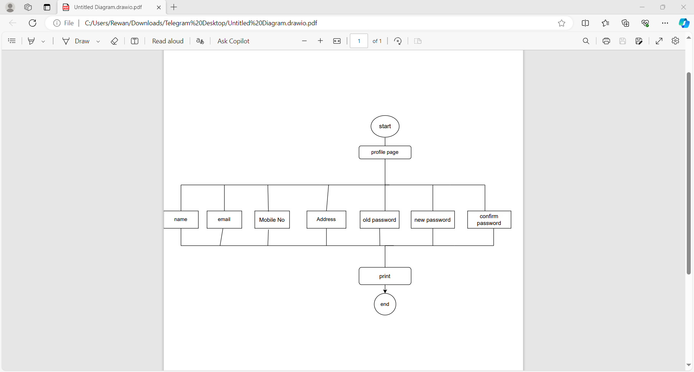

**13.3Code Snippets:**

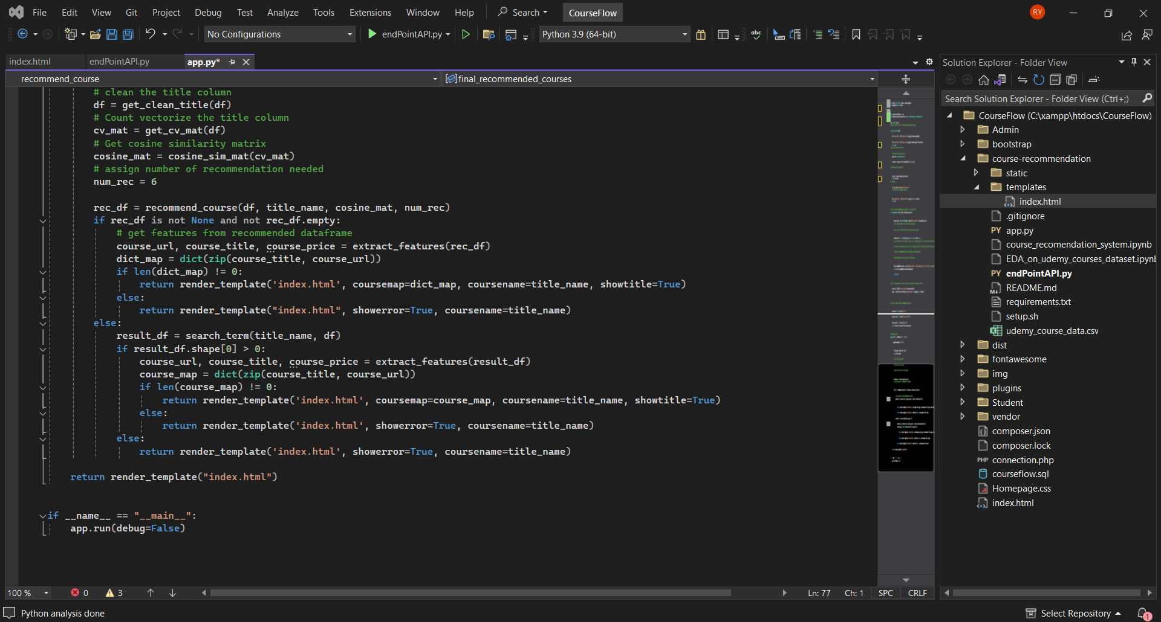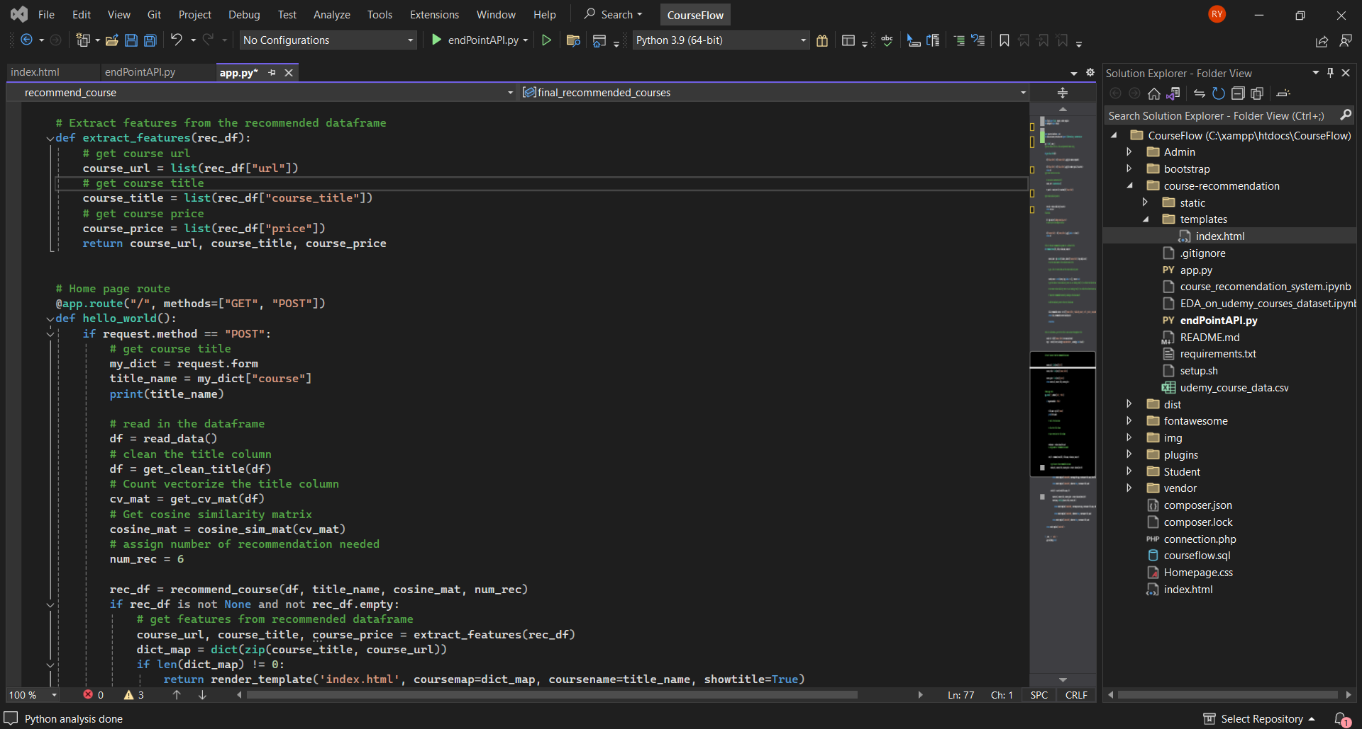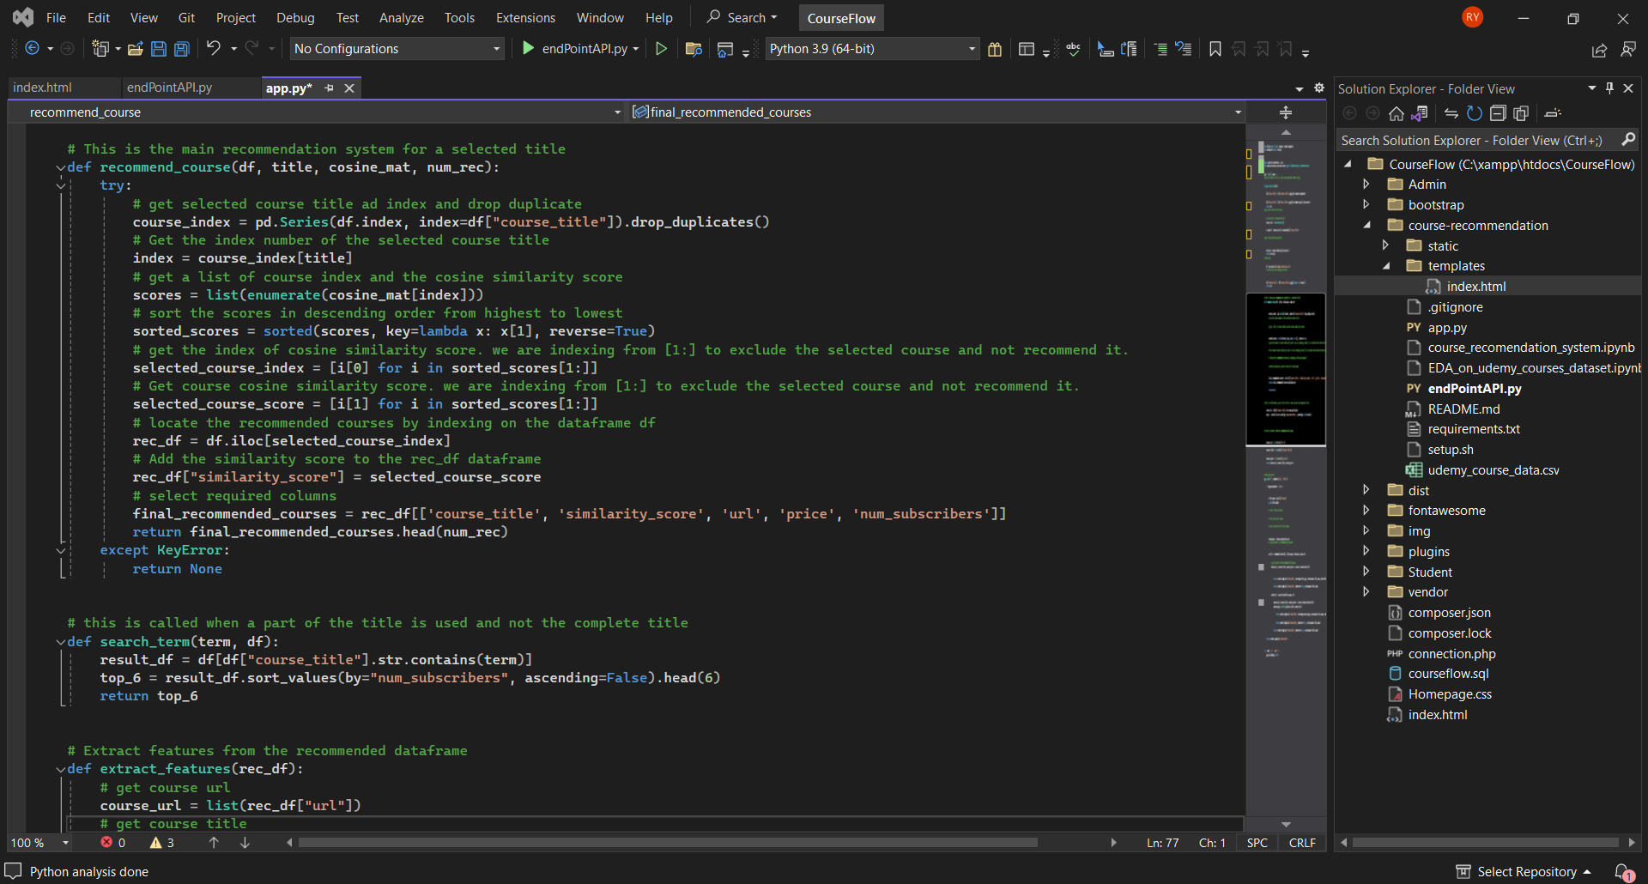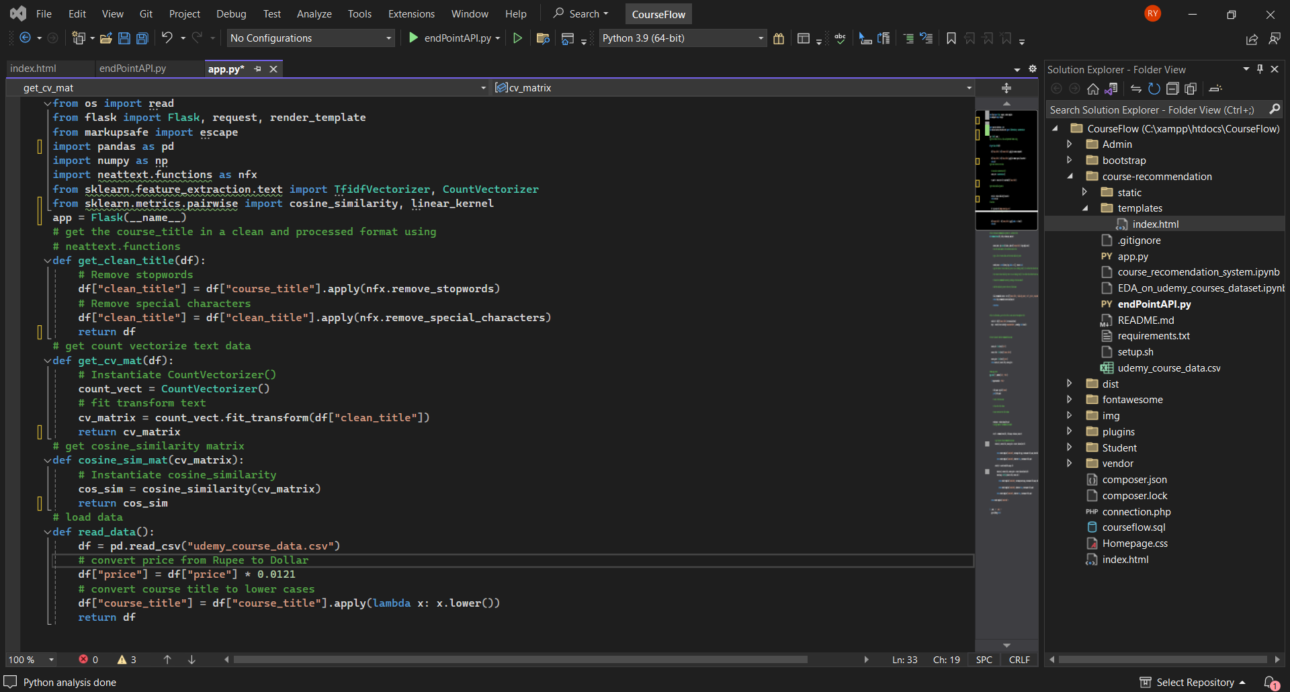**1.1AI Course Recommendation:**

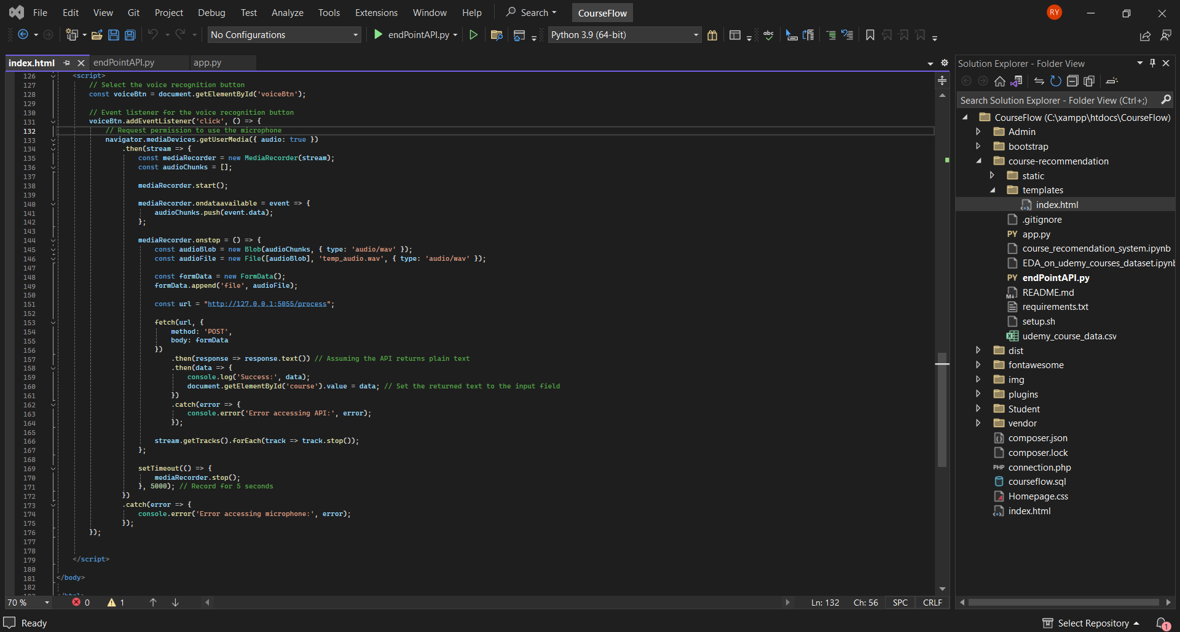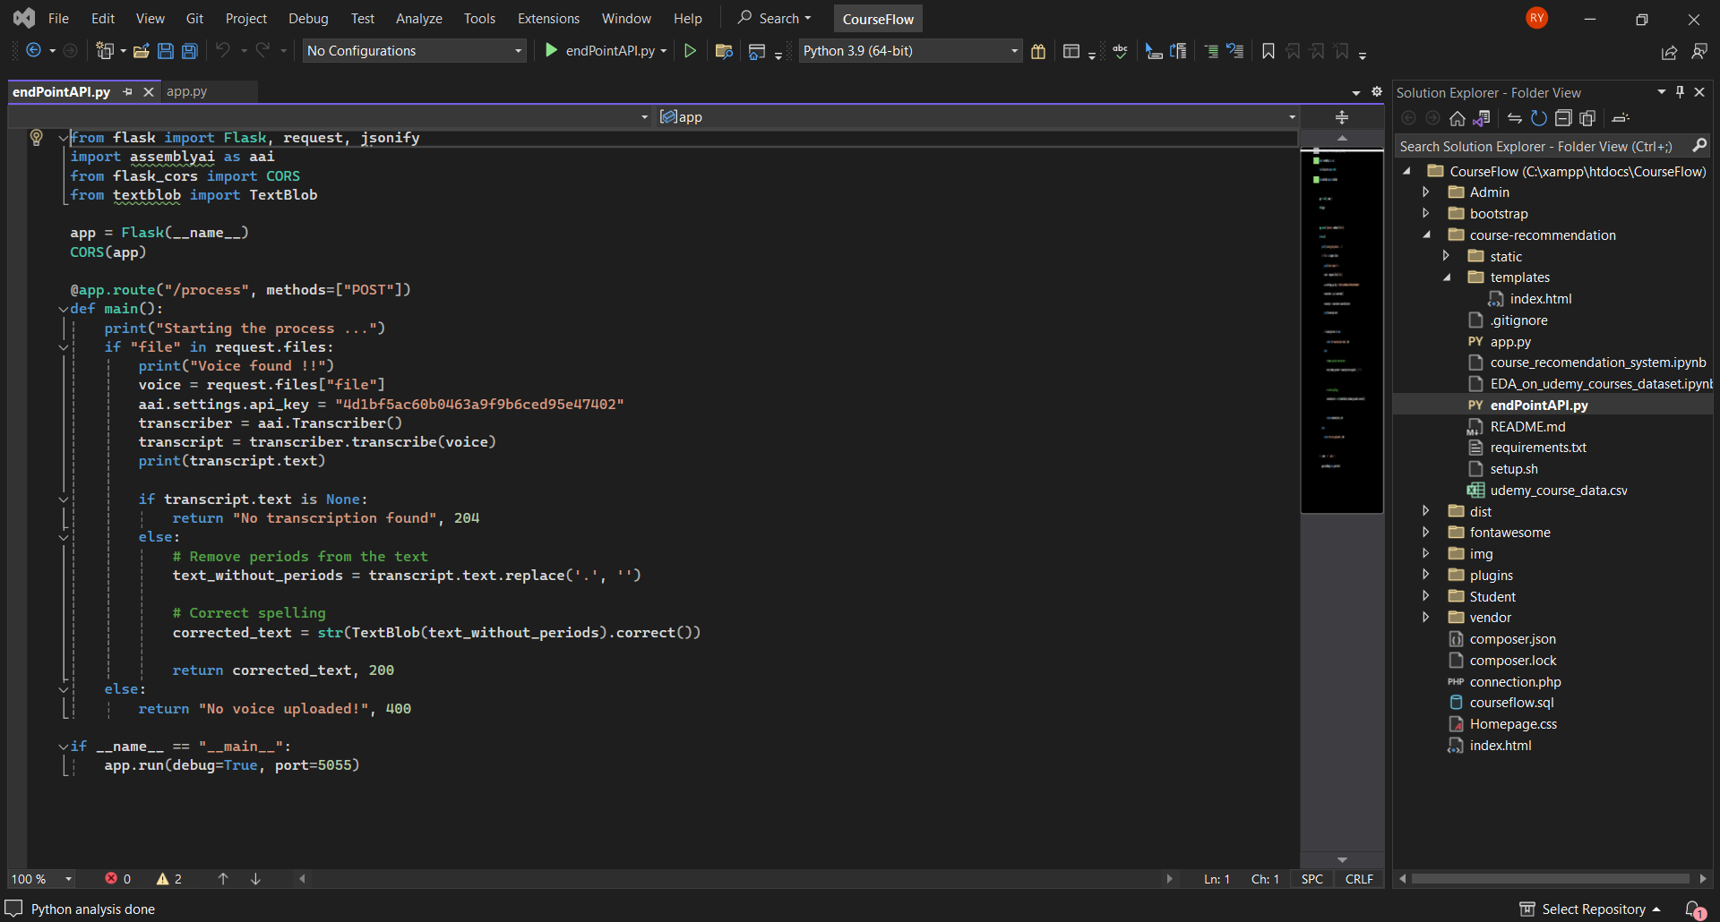**1.2AI Speech-To-Text**

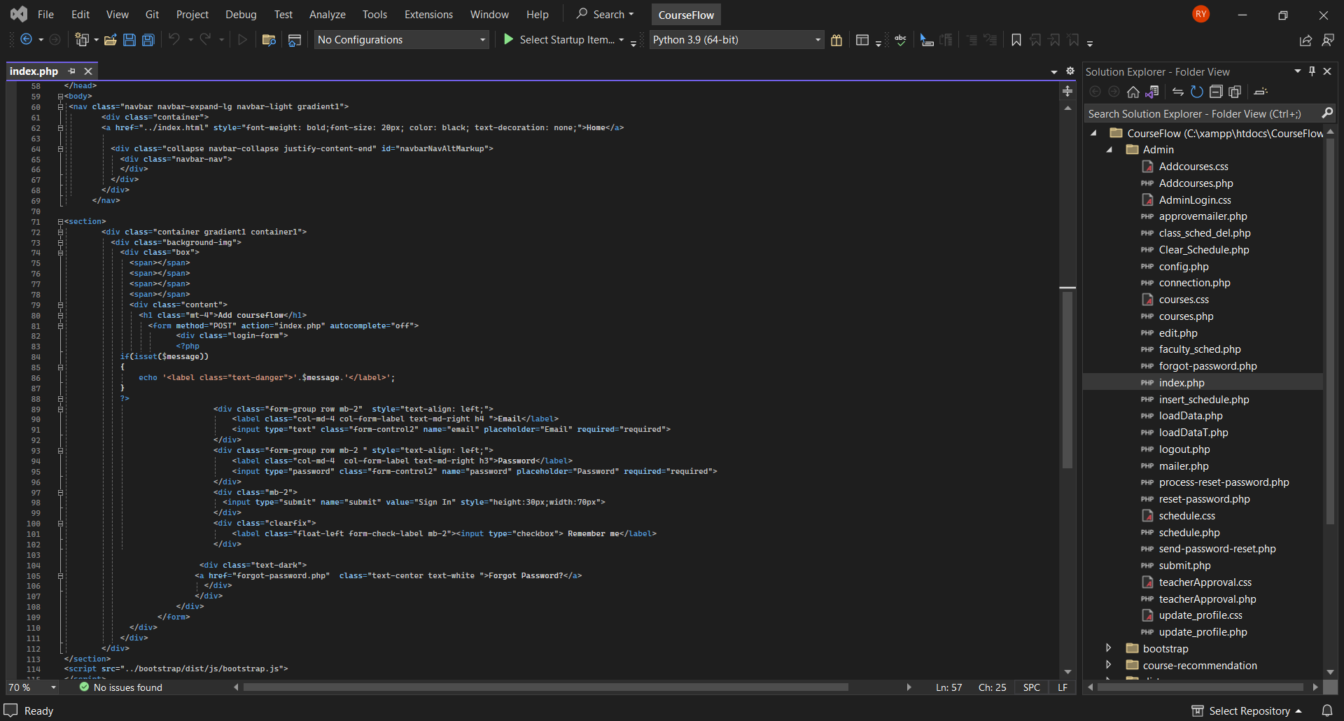**2.Admin Side**

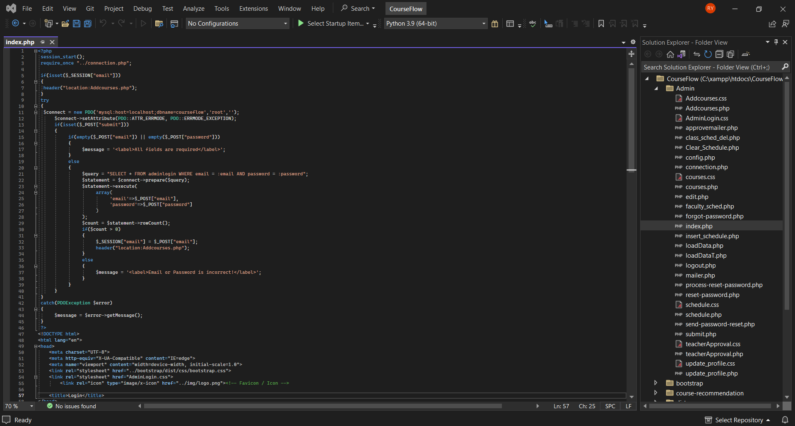**login**

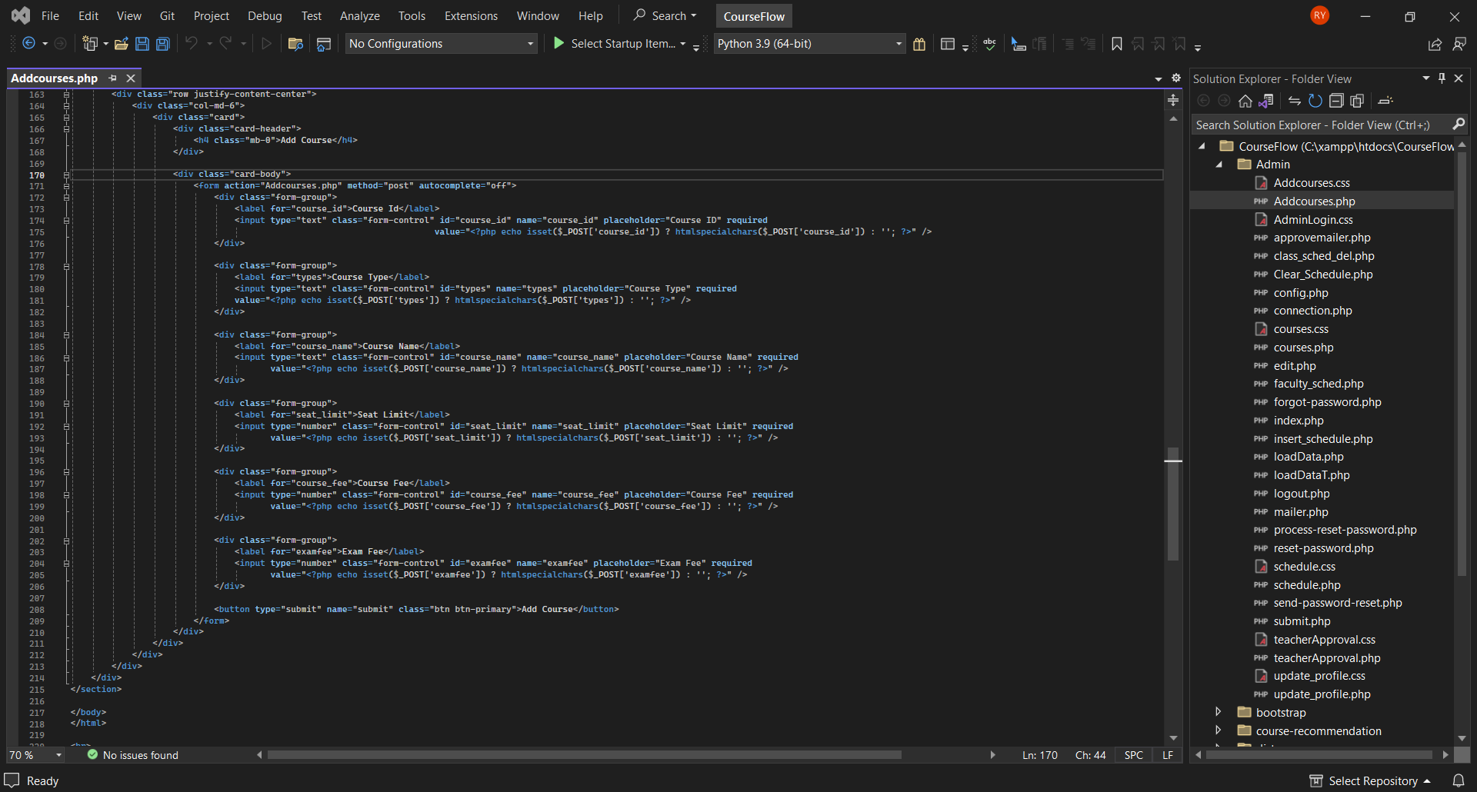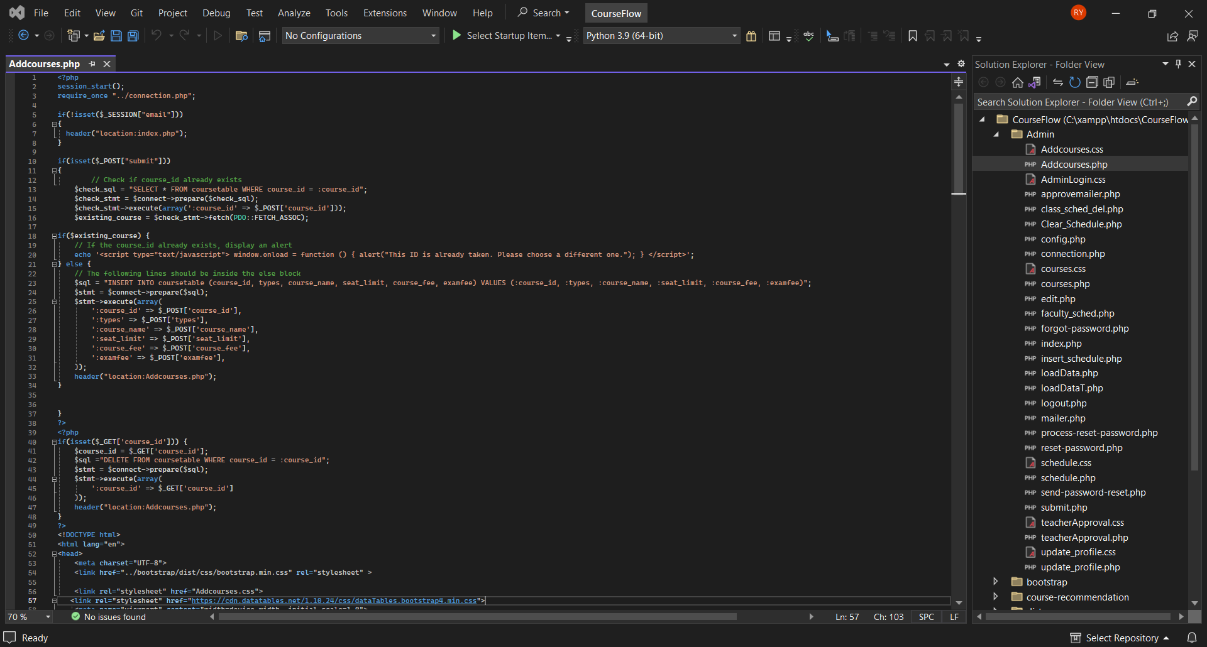**Add course**

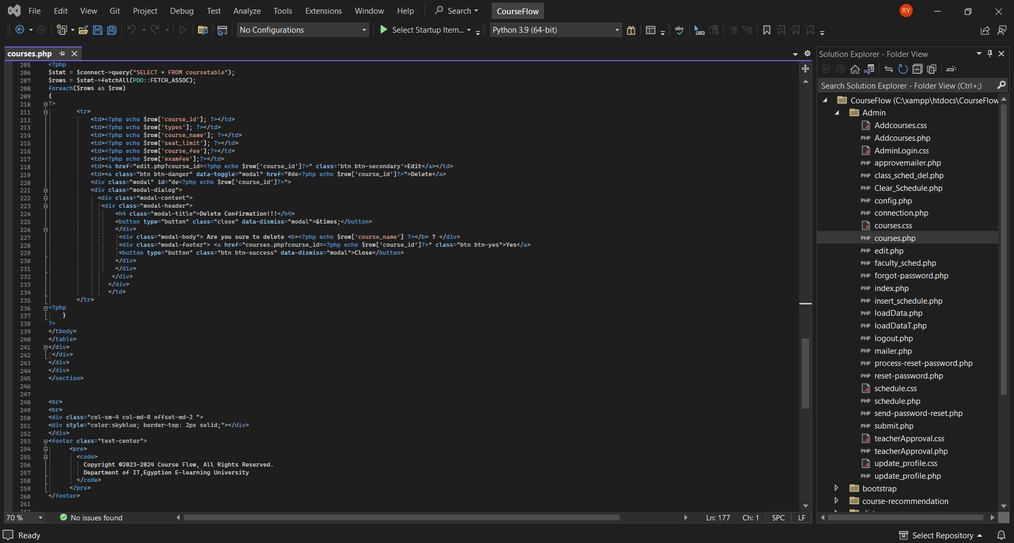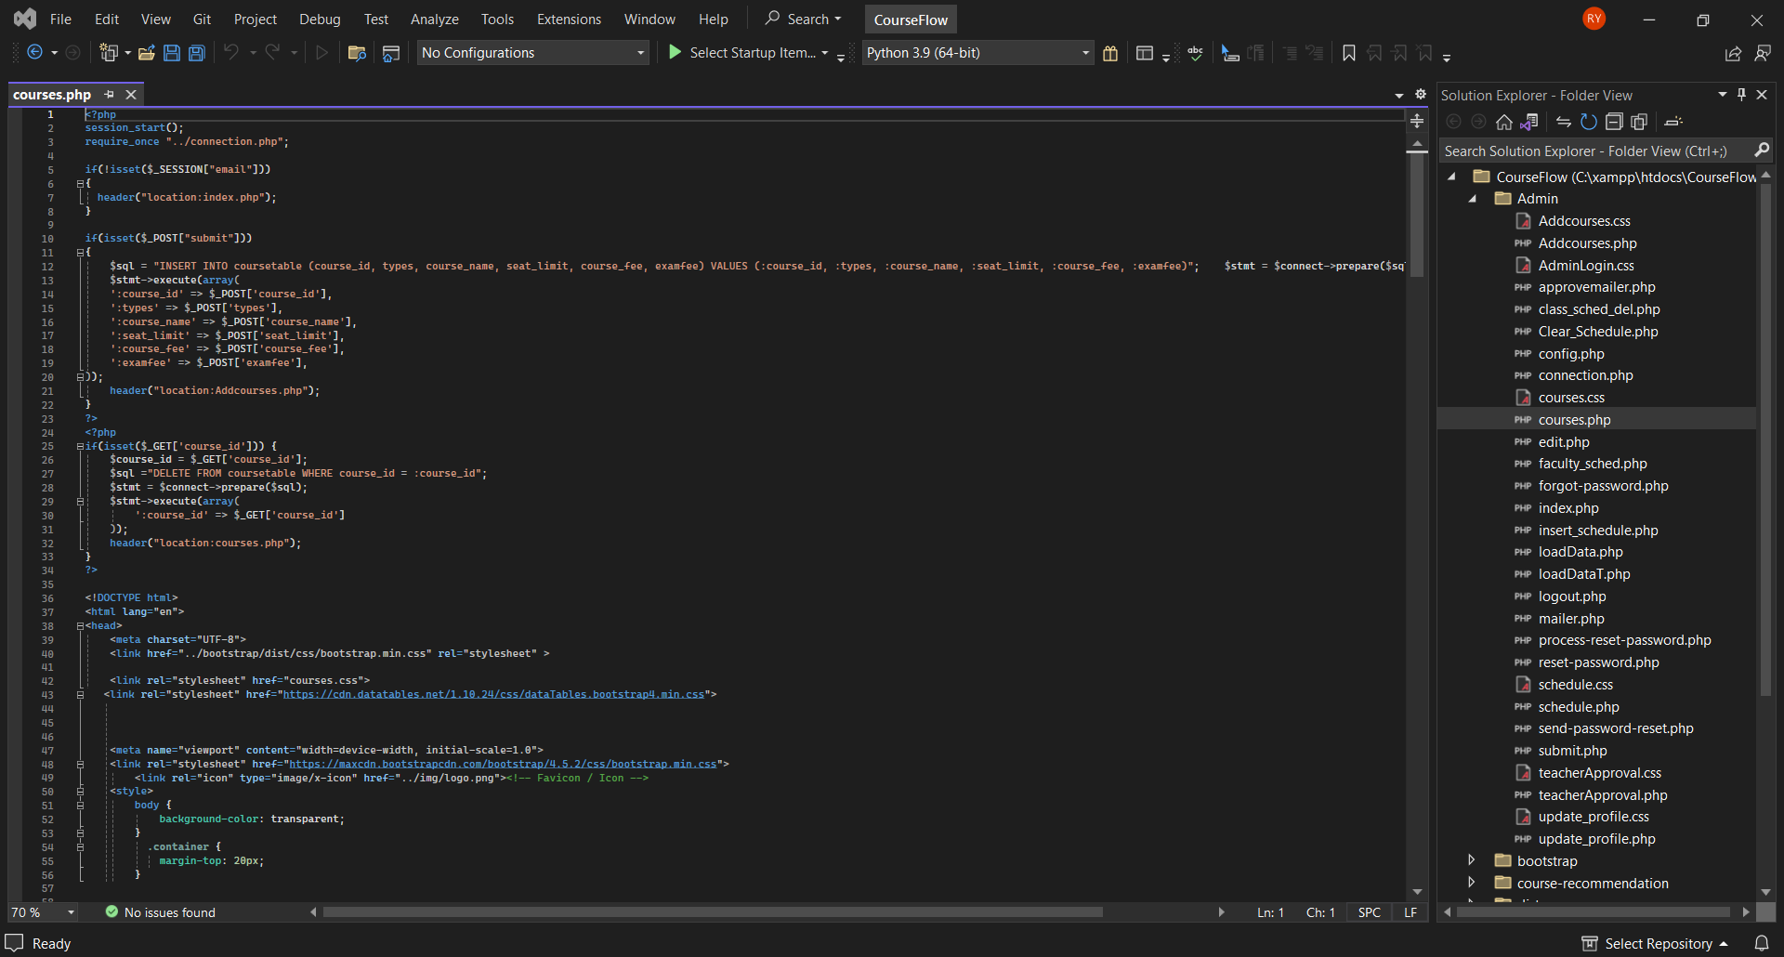**Courses**

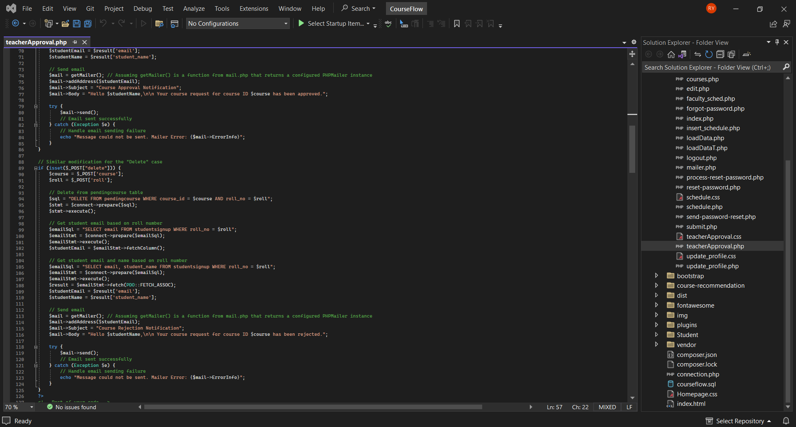**Approval**

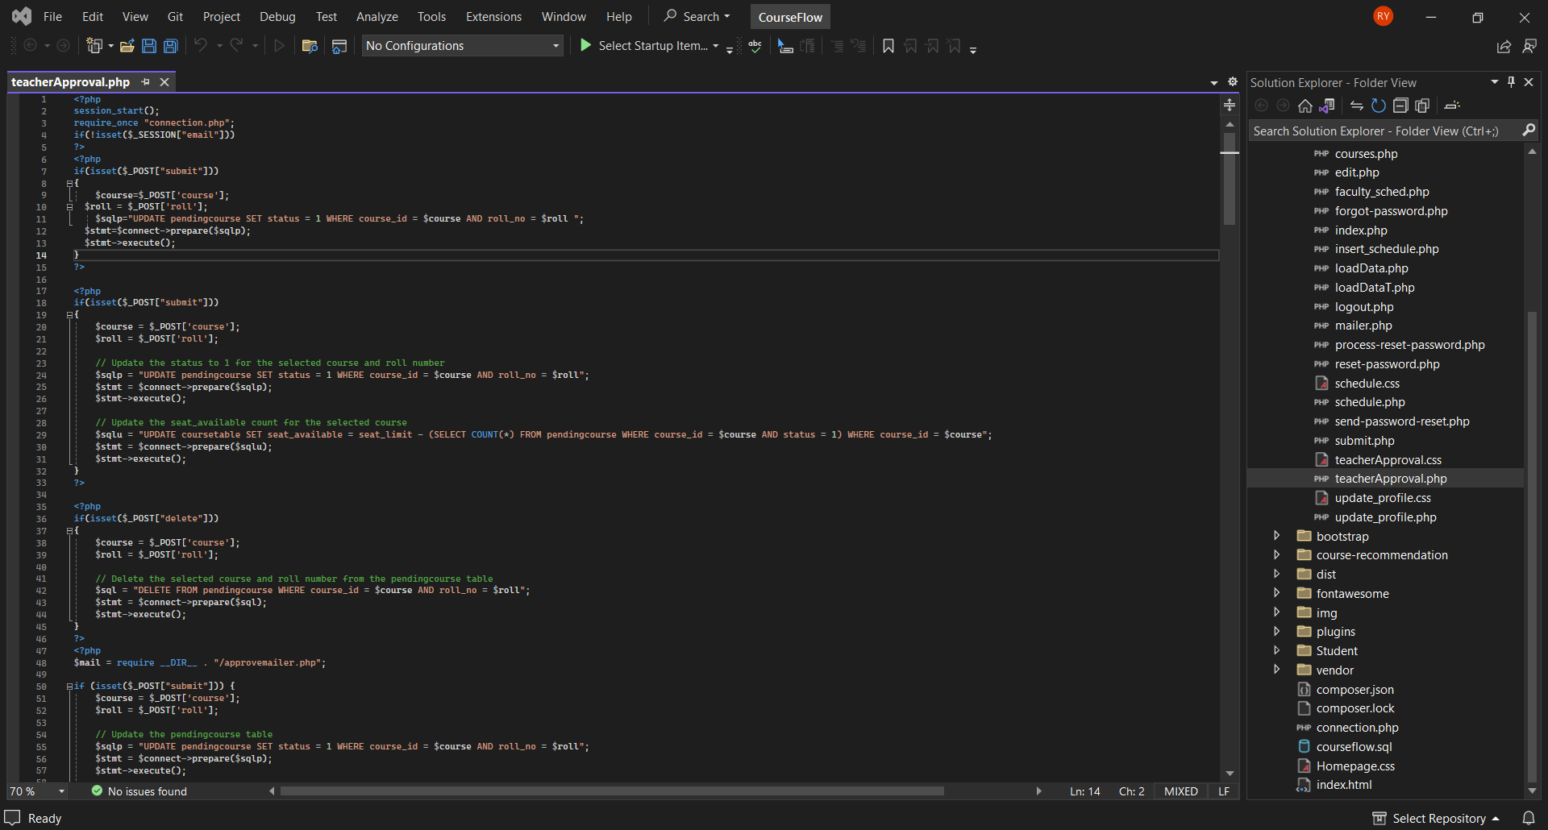

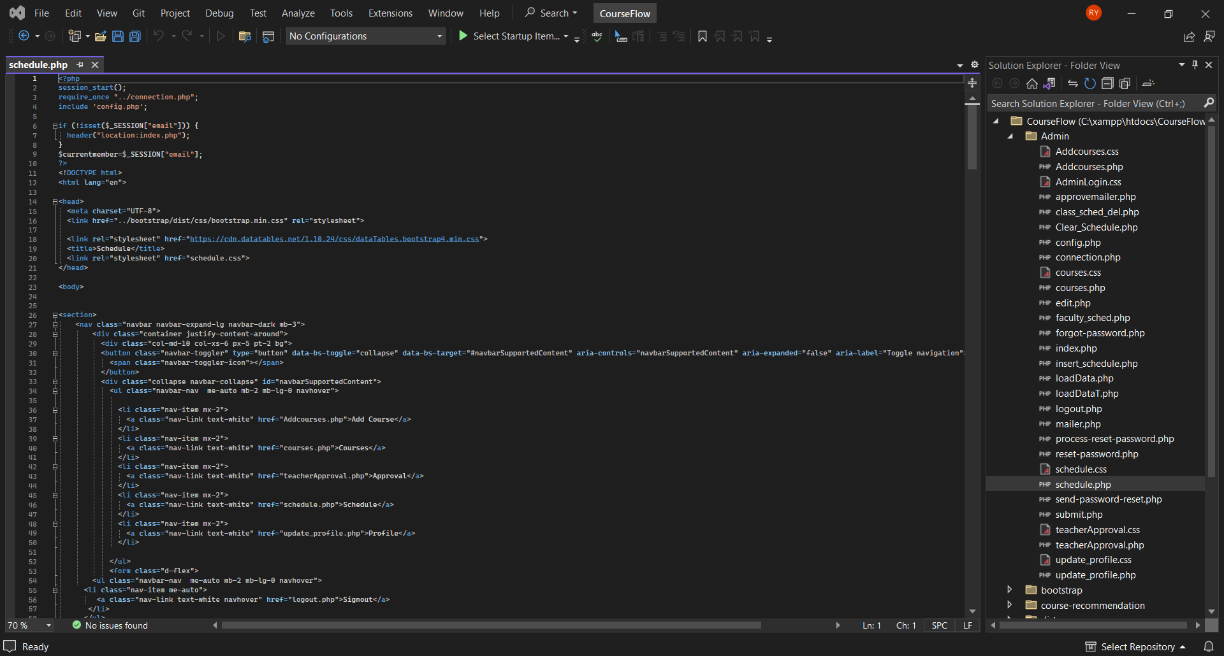**Schedule**

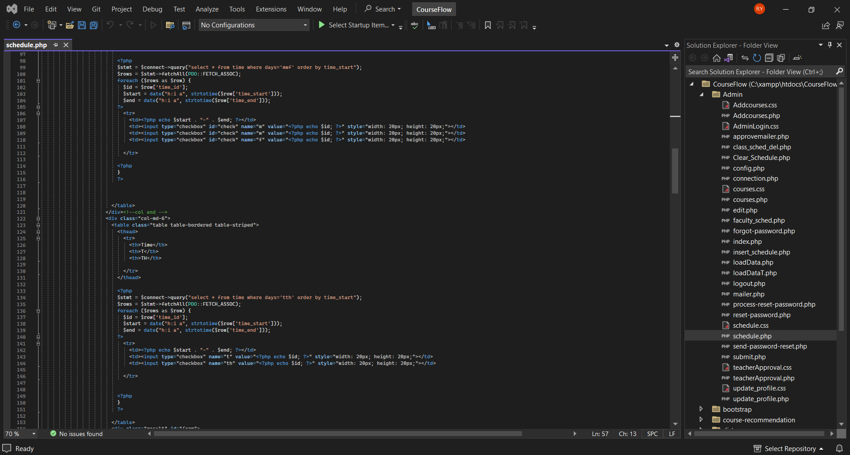

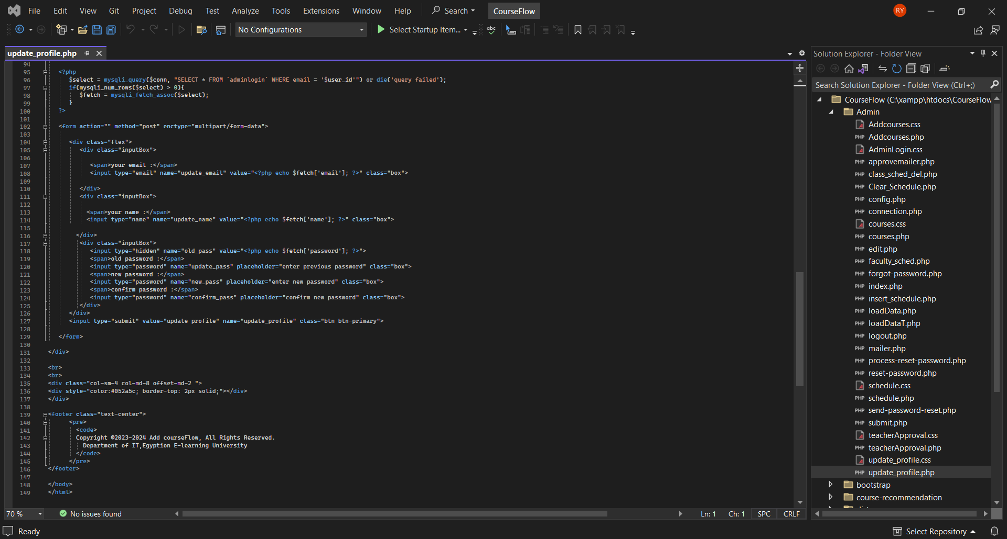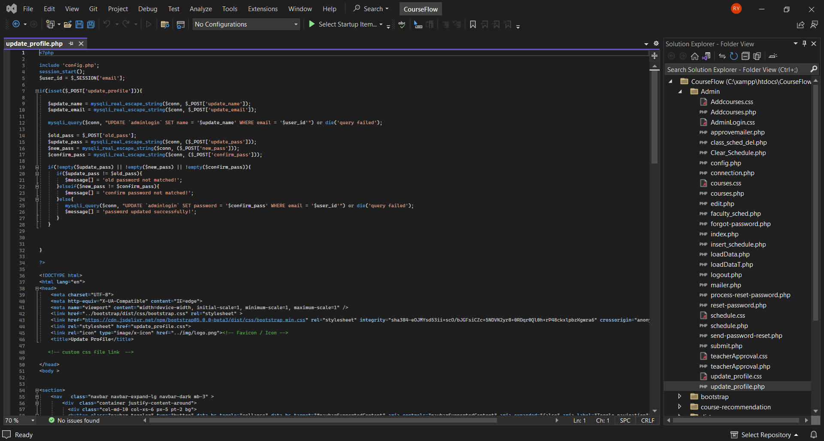**Profile**

**3.Student Side**

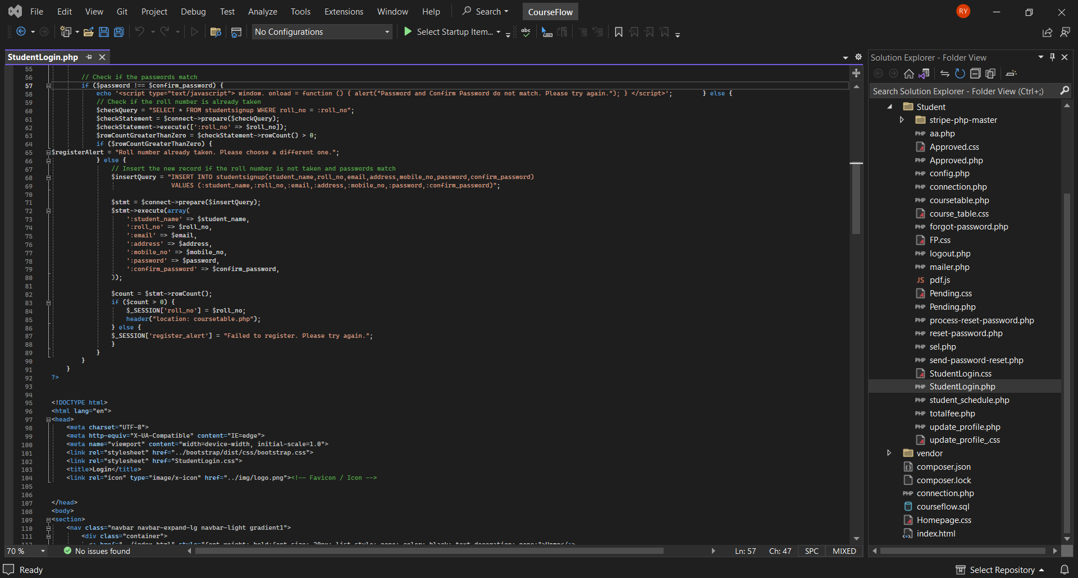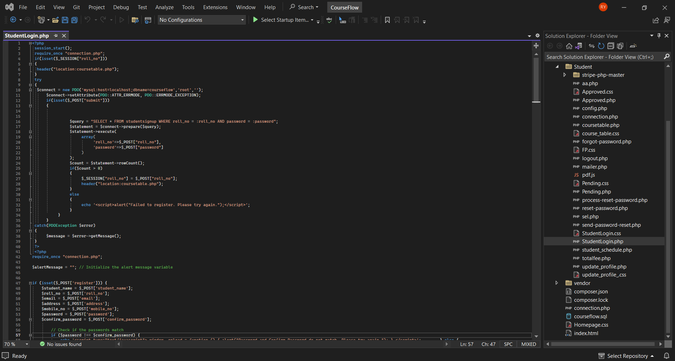**Login**

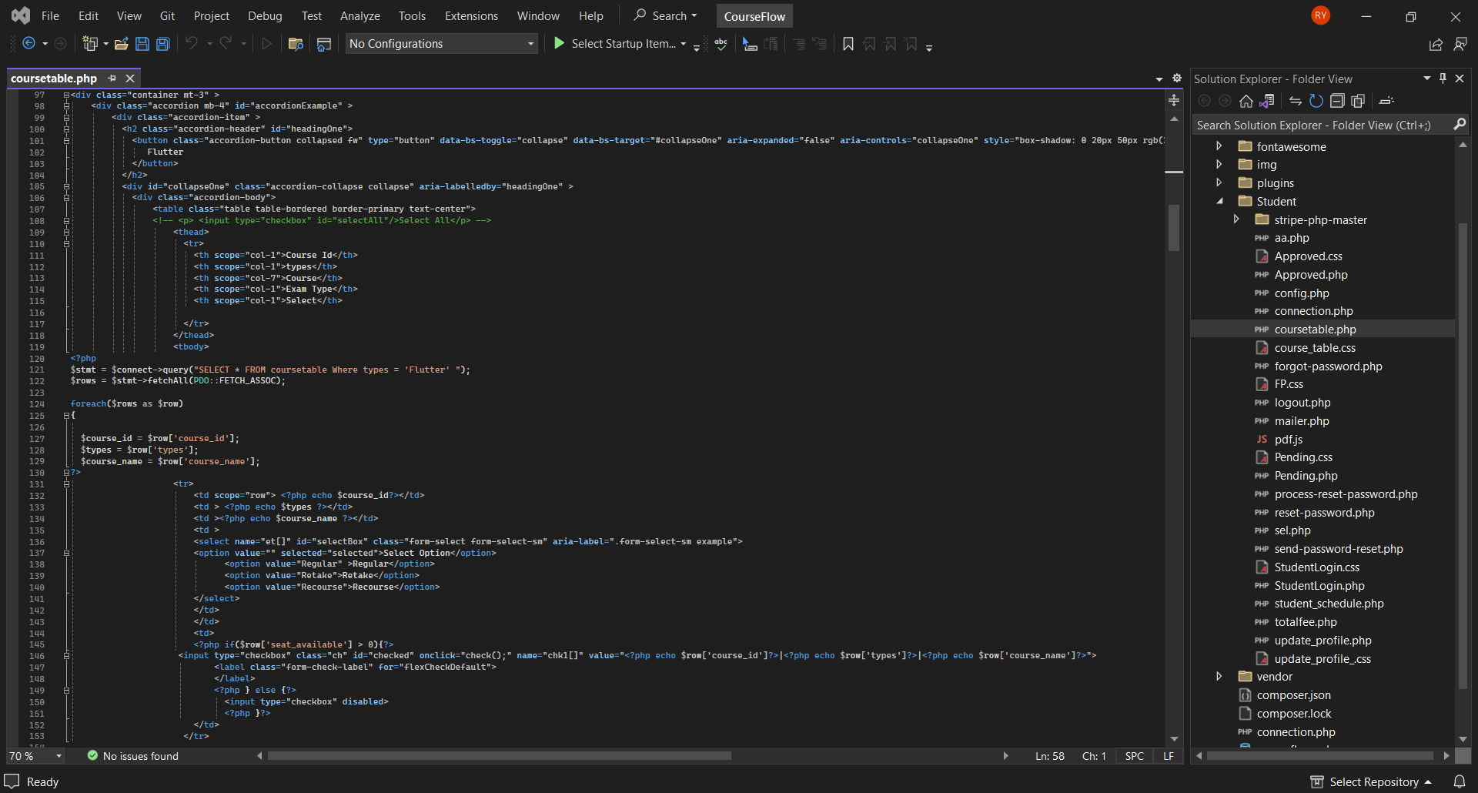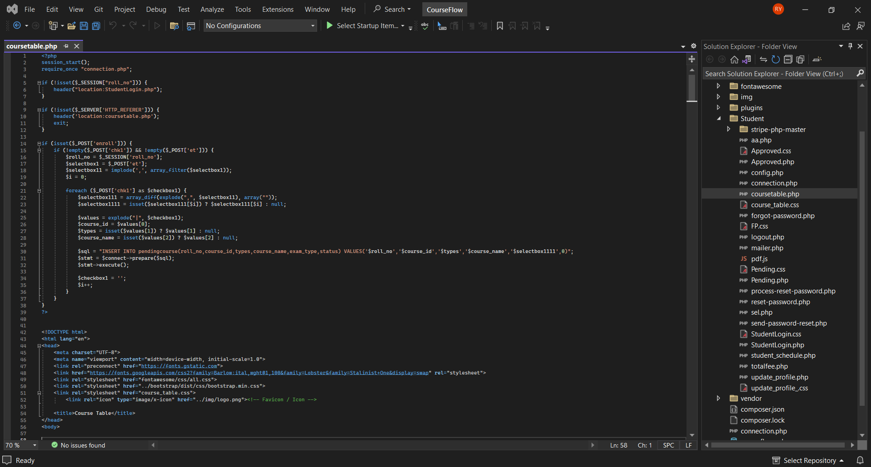**Select Courses**

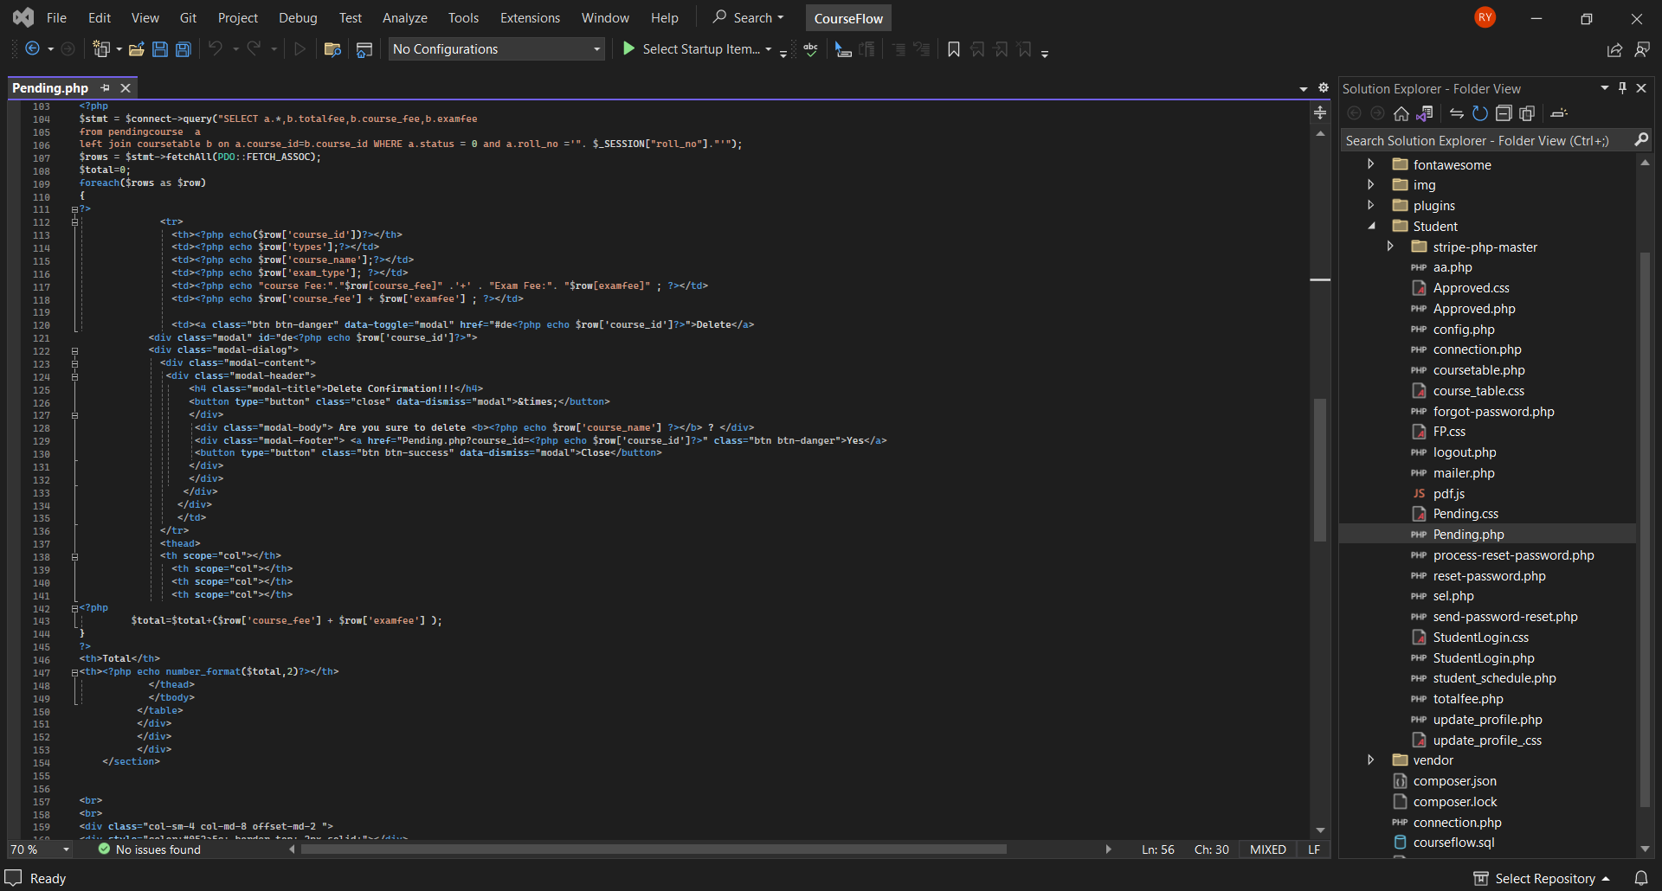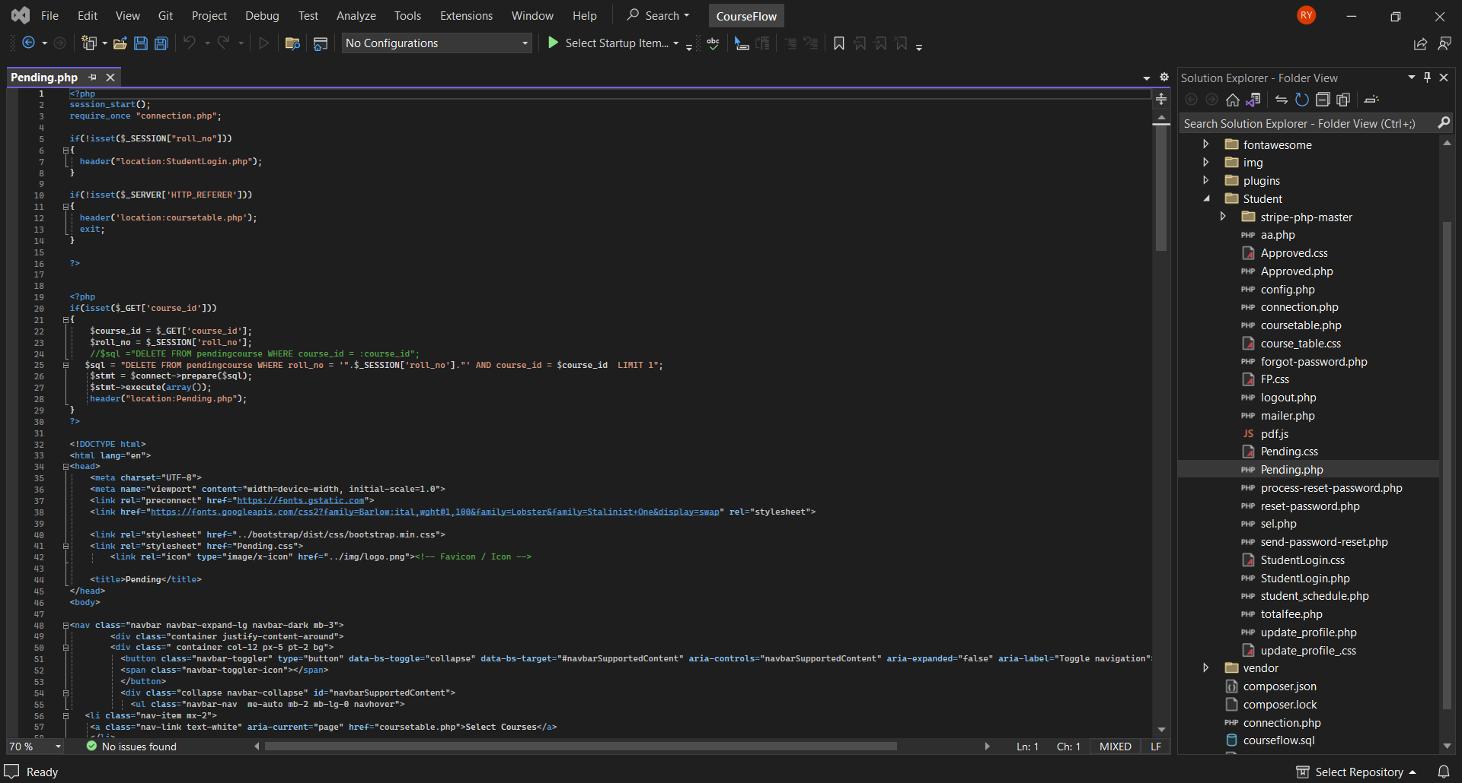**Pending Courses**

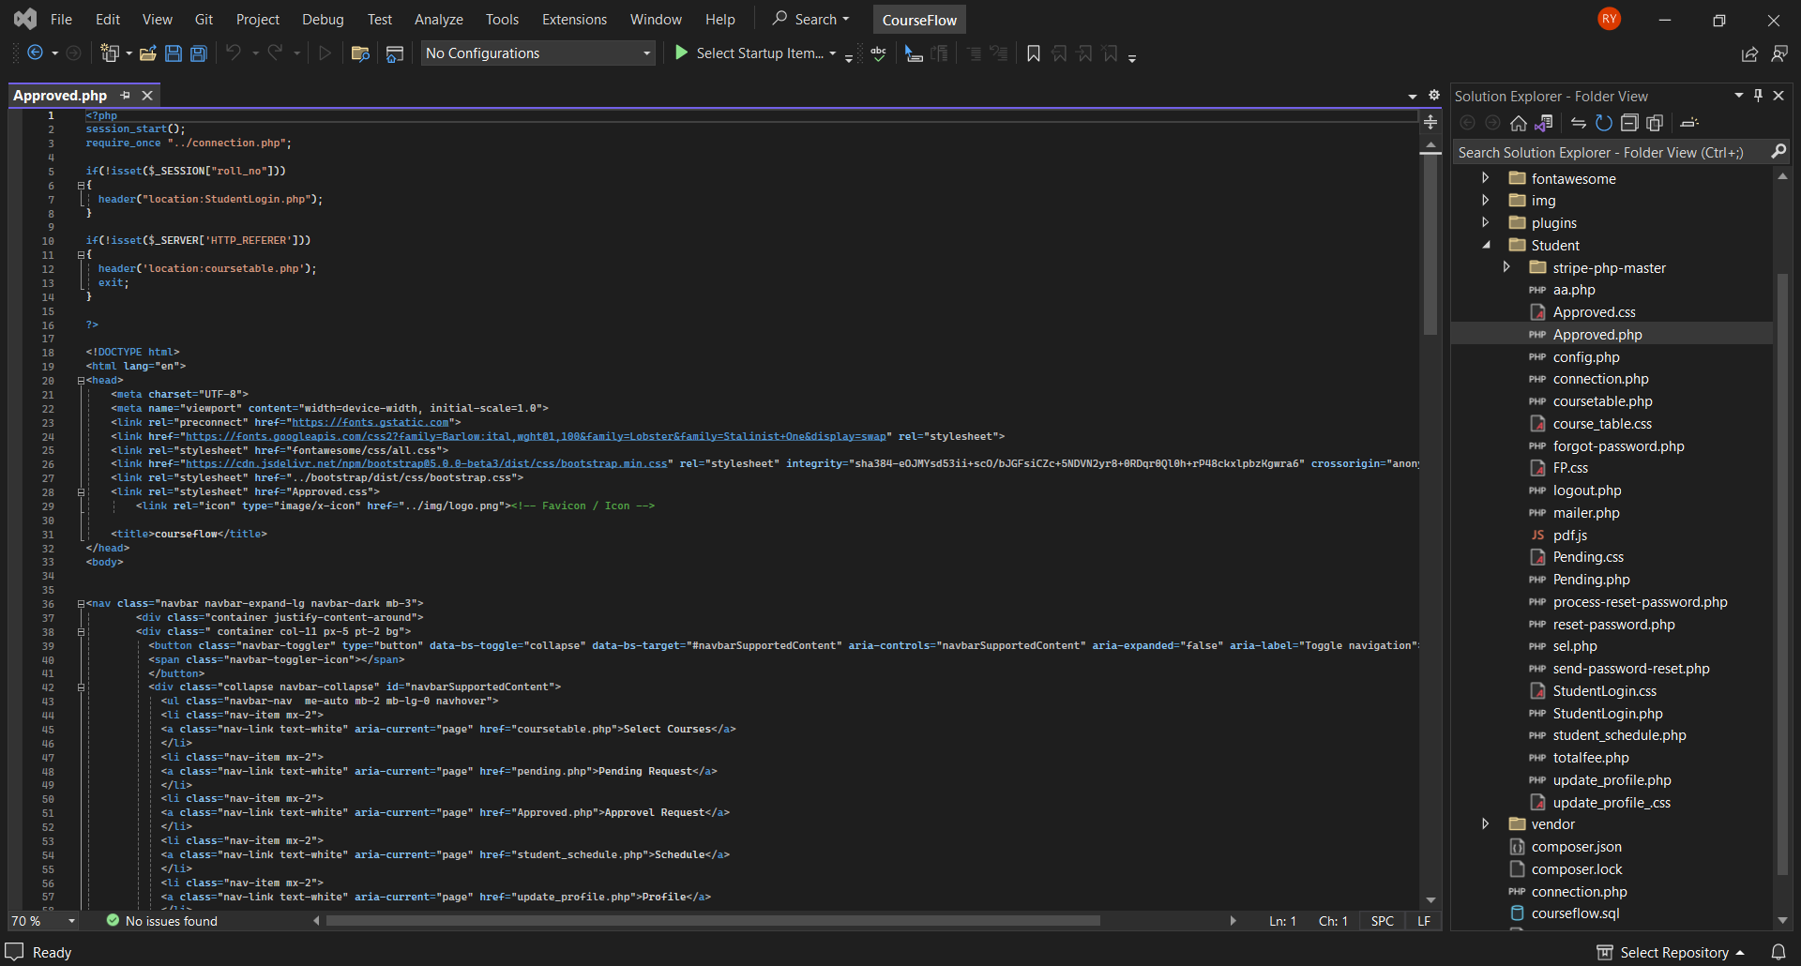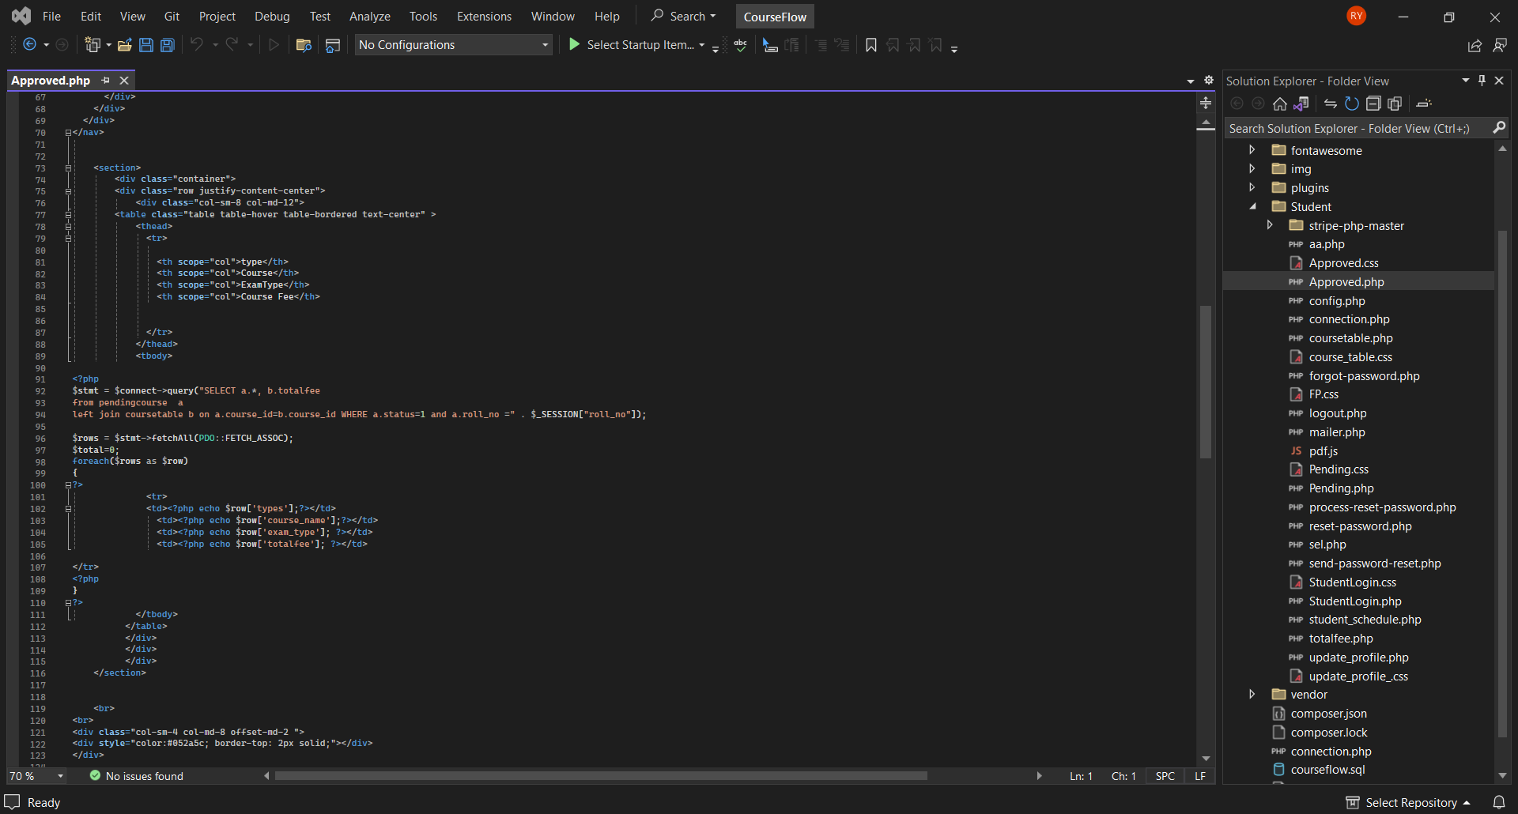**Approved Request**

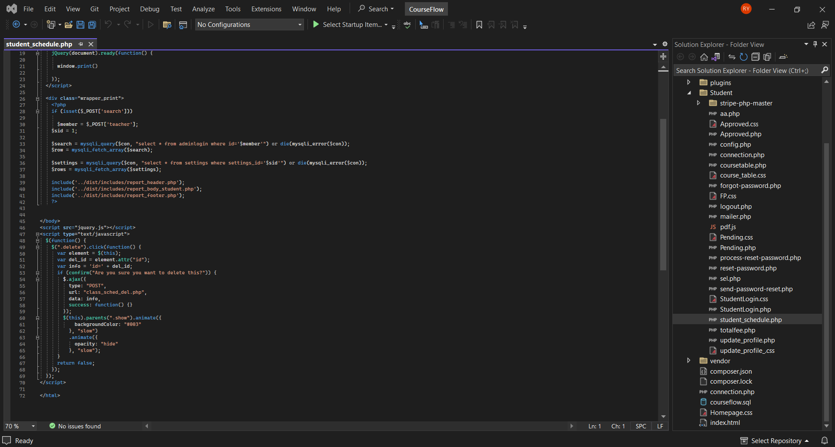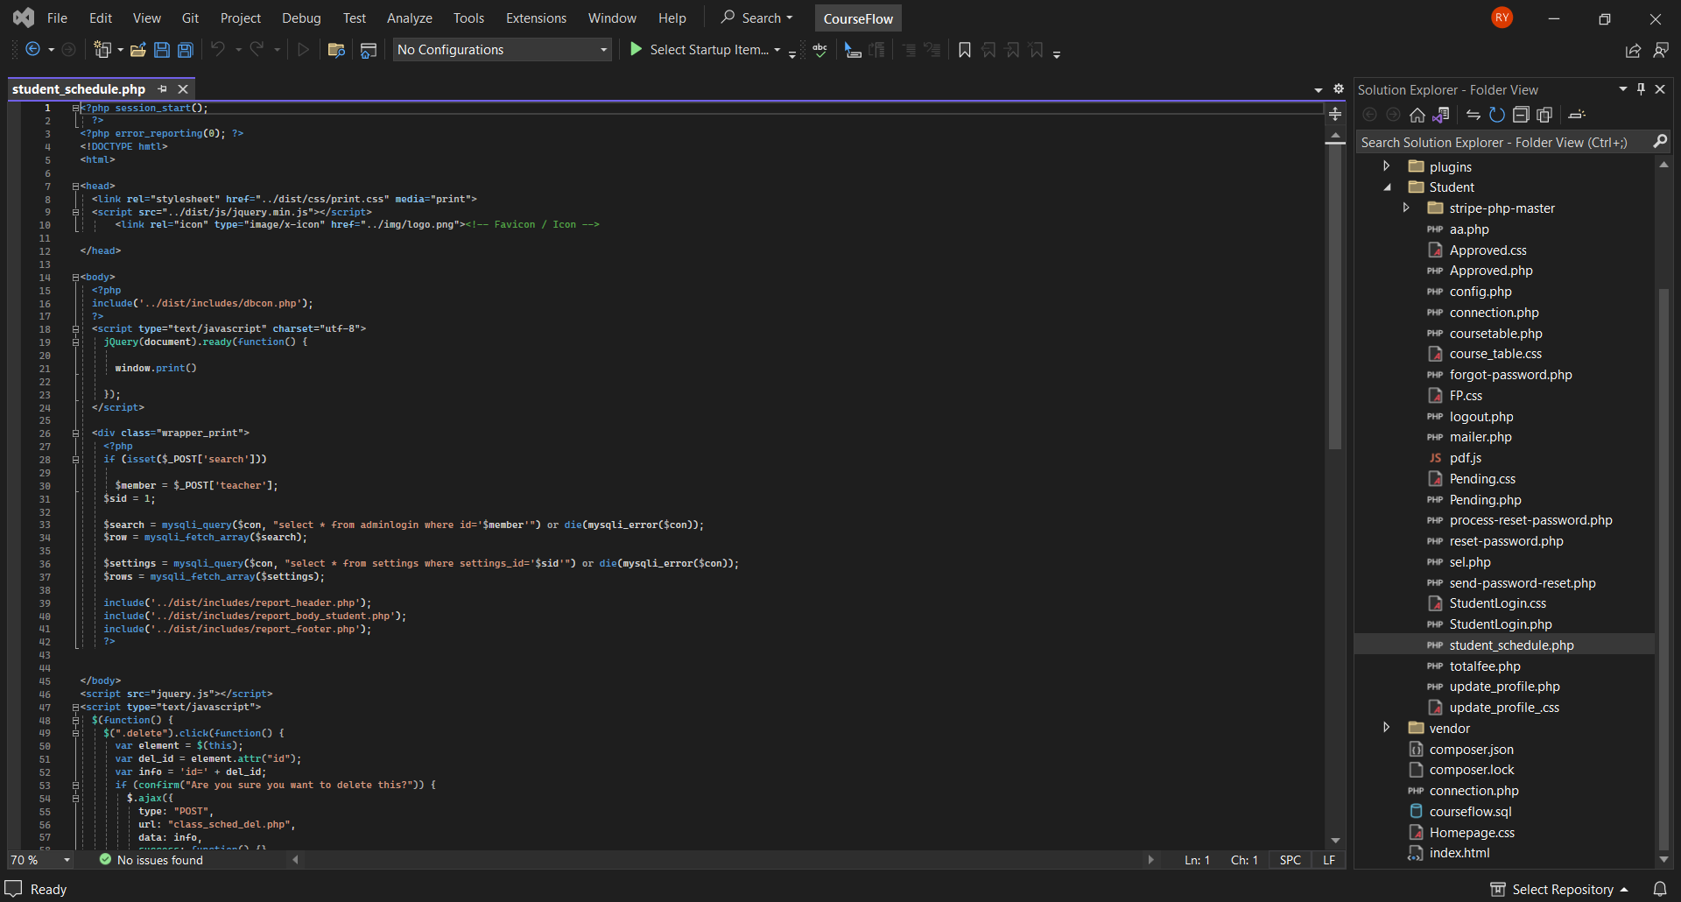**Schedule**

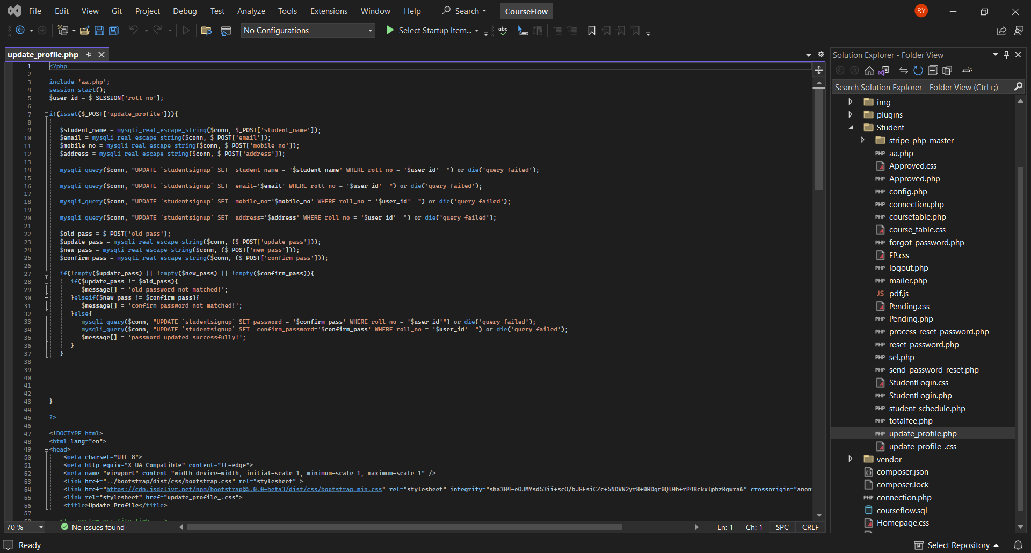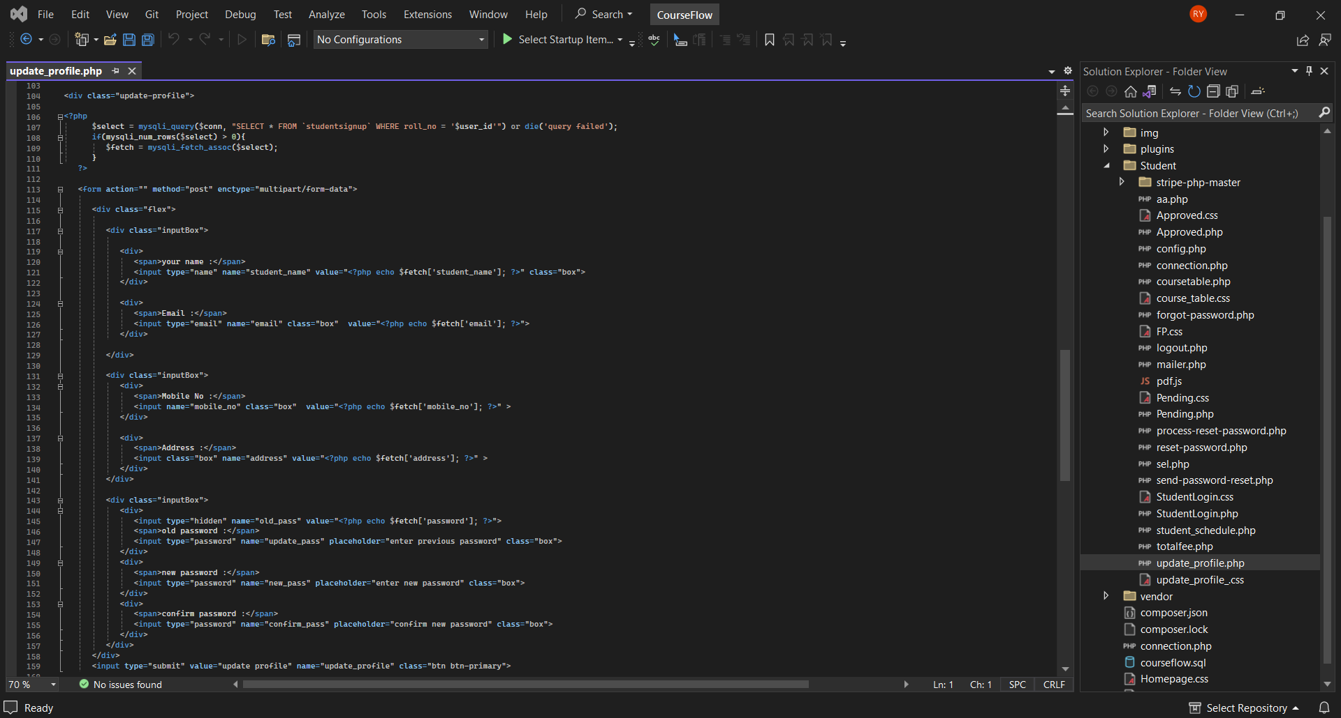**Profile**